Slide 1  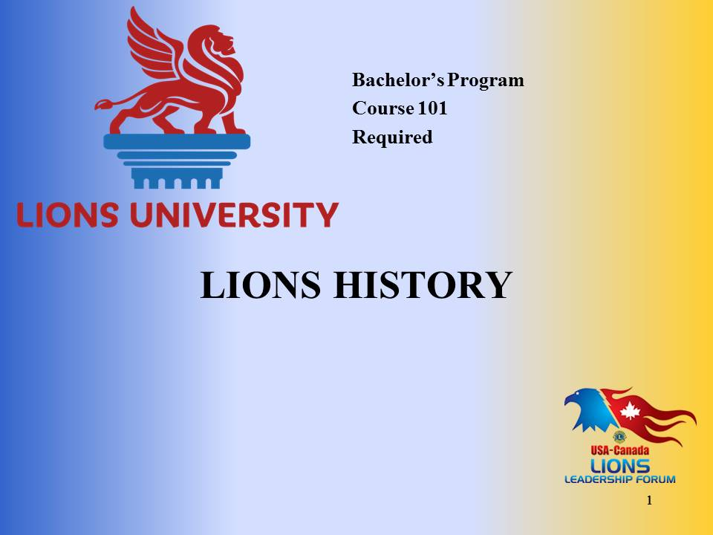 | Welcome to Lions History.  This course content was prepared by PDG Judy Dudley from Multiple District 8, Louisiana for Lions University and the USA/Canada Lions Leadership Forum.  This material has been made available for District and Multiple District leadership development.  You will be able to get credit for participating in this live seminar through Lions University by later taking an online quiz.
Slide 2  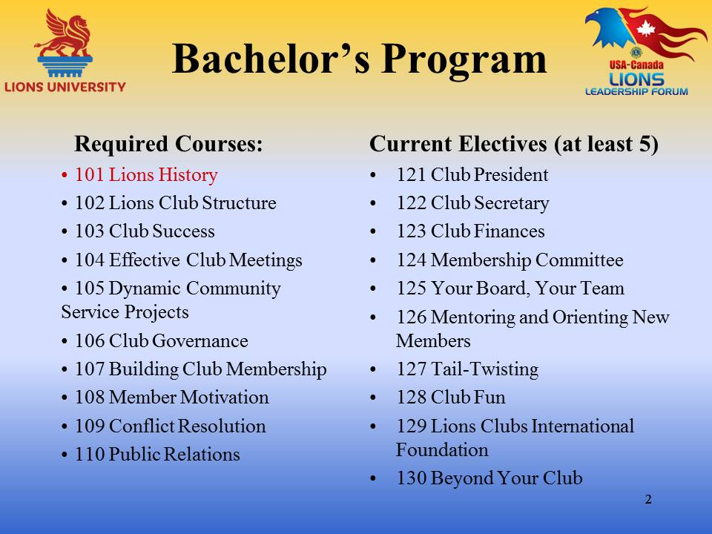 | Lions History is course #101, a required course for the Lions University Bachelor’s Program that is designed to help Lions lead at the club level.  The Bachelor’s Program involves the completion of ten required courses and at least five elective courses.
Slide 3  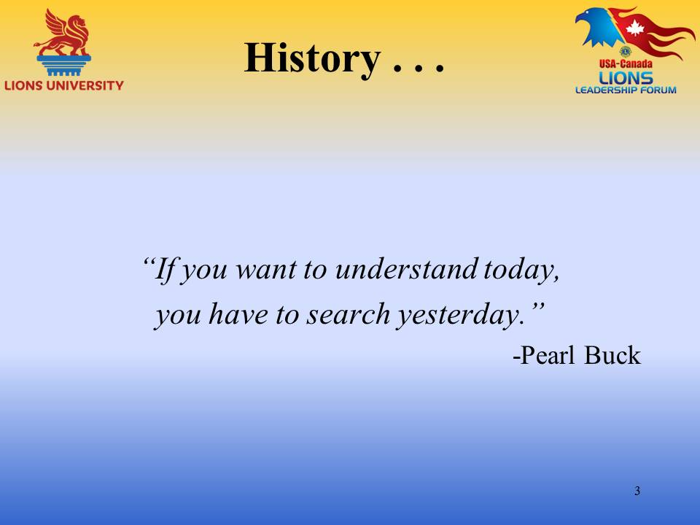 | “ If you want to understand today, you have to search yesterday.” – Pearl Buck  Today we are going to look at a very abbreviated history of Lions in the light of some historical quotes by some individuals that you will recognize immediately, and others that many of us have never heard of. I hope that you have as much fun seeing how well these words of others pertain to our fellow Lions and to the situations throughout our association’s history.  In the short time of this course, I would like to share with you some of the lesser known facts about our history, the story behind the story so to speak. I have posted the well-known information on the Lions U website for your further information. So now let’s look at the task before us.
Slide 4  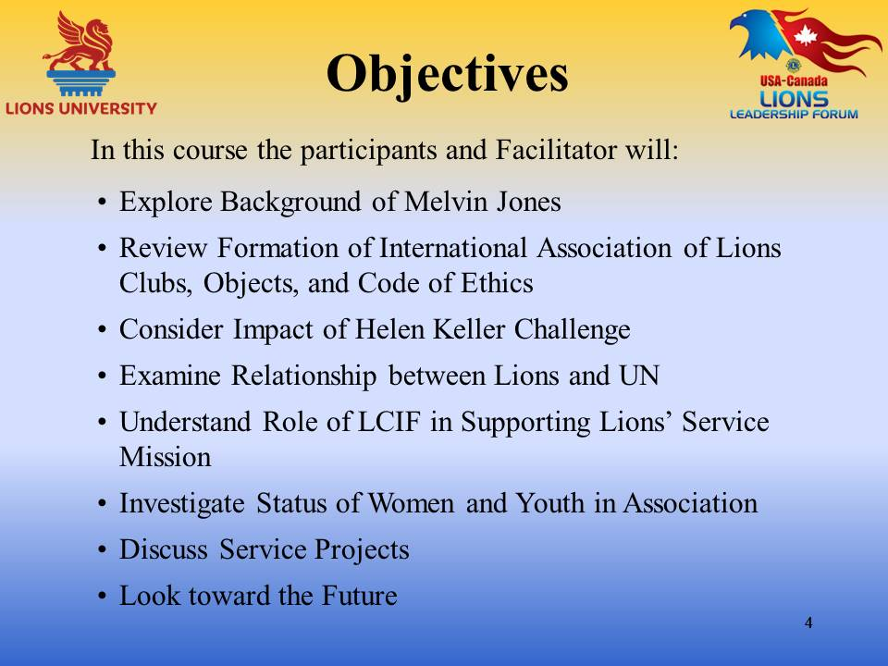 | Objectives:  - Explore Background of Melvin Jones  - Review Formation of International Association of Lions Clubs, Objects, and Code of Ethics  - Consider Impact of Helen Keller Challenge  - Examine Relationship between Lions and UN  - Understand Role of LCIF in Supporting Lions’ Service Mission  - Investigate Status of Women and Youth in Association  - Discuss Service Projects  - Look toward the Future
Slide 5  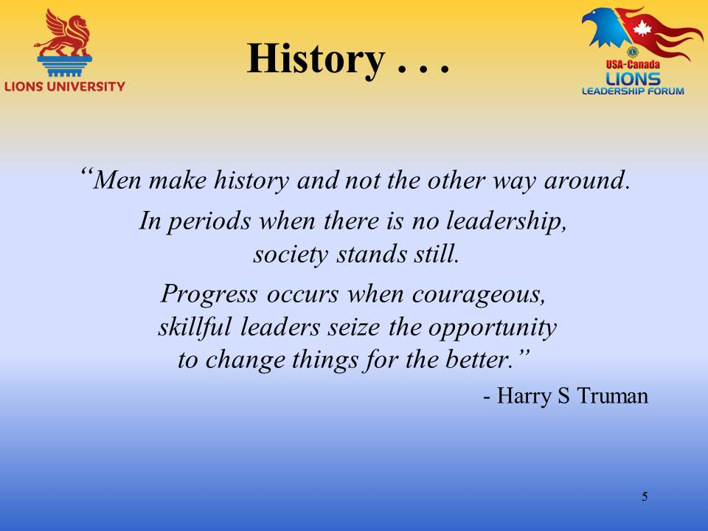 | “Men make history and not the other way around. In periods when there is no leadership, society stands still. Progress occurs when courageous, skillful leaders seize the opportunity to change things for the better.” - Harry S Truman I chose this quote because of the reference to the need for leadership in order for society to progress. Leadership will certainly be evident as we consider the first slide.
Slide 6  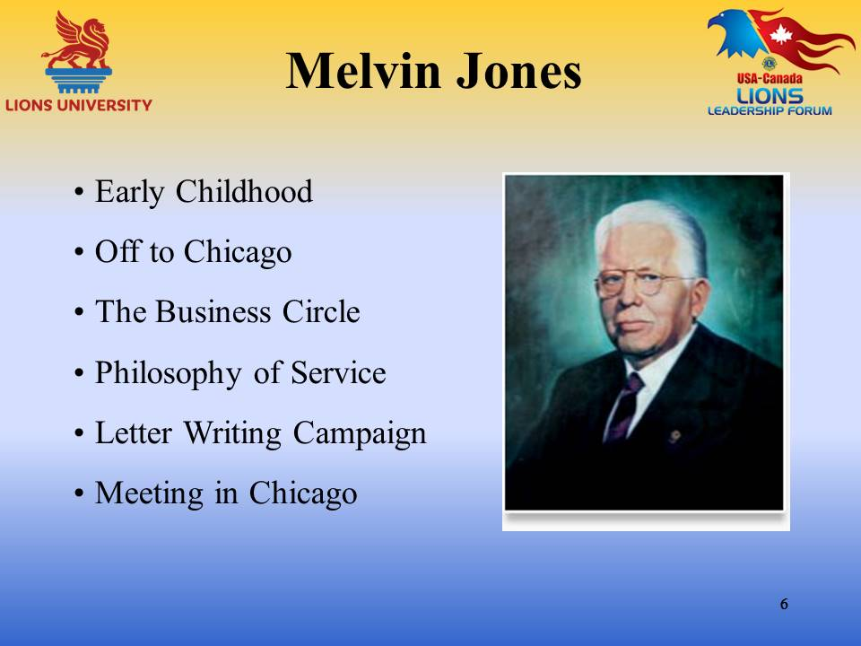  Slide 6 (continued)  Slide 6 (continued) | Melvin Jones: The founder of Lions Clubs  Early Childhood – Melvin Jones was born on January 13, 1879 to Captain Calvin and Lydia Jones in the Calvary Outpost at Fort Thomas, Arizona. The area around Fort Thomas was a difficult place to live especially with a young and adventuresome child. There were frequent skirmishes with Indians and other problems typical of living on the frontier. In 1888 the Jones family moved to Saint Louis, Missouri and later to Quincy, Illinois. Young Melvin attended schools in both places. His education continued at Union Business College and also Chaddock College in Quincy.  Off to Chicago – Melvin Jones who had a good tenor voice couldn’t decide whether he should continue with a law career or turn to music. Choosing neither when he was 20 years old he moved to Chicago where he was employed by the Johnson and Higgins Insurance Agency. He worked very hard but was paid very little. Melvin Jones was an intelligent and alert young man and after 10 years he had opened his own agency, Melvin Jones Insurance, and was quite successful. He was married to Rose Amanda Freeman.  The Business Circle – As a young and successful business man, Melvin Jones was invited to join the Business Circle of Chicago. The Business Circle was one of the lunch clubs that were active, not only in Chicago, but also in other large cities throughout the country. These lunch clubs followed the principle of “classification by occupation” which meant that members would provide help to the other members. Melvin Jones was invited when the previous member in his occupation transferred to a different organization in another city. The sole purpose of these clubs was to network and promote each other’s businesses. In fact Kittler reports that: the slogan of the Business Circle “was an unabashed ‘You scratch my back, and I’ll scratch yours.’” As a member of the Business Circle Melvin Jones was involved in mediating differences among members and was recognized as a leader in the club. He was elected club secretary which had the duty of corresponding with secretaries of other similar clubs mostly on behalf of executives seeking connections elsewhere.  Philosophy of Service – Melvin Jones was a gifted salesman and didn’t need a club card to earn a living. Kittler reports that he probably joined the Business Circle because of the fellowship and friendship that it provided. He was a skillful organizer and had a deep sense of duty. Kittler further indicated that it soon irked him to belong to a group whose sole purpose was personal profit and that Melvin Jones started thinking “What if these men, who are successful because of their drive, intelligence, and ambition, were put to work helping improve their community?’ He started urging the members to participate more in civic affairs as well as inserting his own philosophy on what clubs should be doing for their communities into his letters to other secretaries.  Letter Writing Campaign – Early in 1917 the Business Circle authorized Melvin Jones to invite other clubs from other cities to a meeting in Chicago to discuss the affiliation of the independent groups into a single association that would be a local, national and international community service organization. Melvin’s wife Rose collaborated with him in sending invitations to existing clubs throughout the country. Even after the first meeting in Chicago they continued writing letters to encourage clubs to embrace the philosophy and to consider becoming part of this new service organization.  Meeting in Chicago – The meeting occurred on June 7, 1917 at the La Salle Hotel in Chicago. At that meeting there were representatives from 4 individual clubs from 4 different cities and The Optimists Clubs (a national organization and the Royal Order of Lions (an international organization). There was a general agreement that the groups did desire to affiliate and form an international organization. The biggest point of discussion was the name. The January 1931 Issue of The Lion contained this interpretation of our name: “Our name was not selected at random, neither was it a coined name. From time immemorial , the lion has been the symbol of all that was good, and because of the symbolism that name was chosen. Four outstanding qualities- Courage, Strength, Activity, and Fidelity had largely to do with the adoption of the name. . . . Fidelity has particular significance for all Lions. . . .It stands for loyalty to a friend, loyalty to a principle, loyalty to a duty, loyalty to a trust.” One interesting point from this meeting; Dr. W.P. Woods, the President of the Royal Order of Lions held the rights over the name LIONS and the pin with the mark of two Lions’ heads. After agreement with Melvin Jones and the Business Circle, he agreed to yield his rights over the name and pin under the privilege of being the first president of the newborn Lions Clubs International (1917-1918).
Slide 7  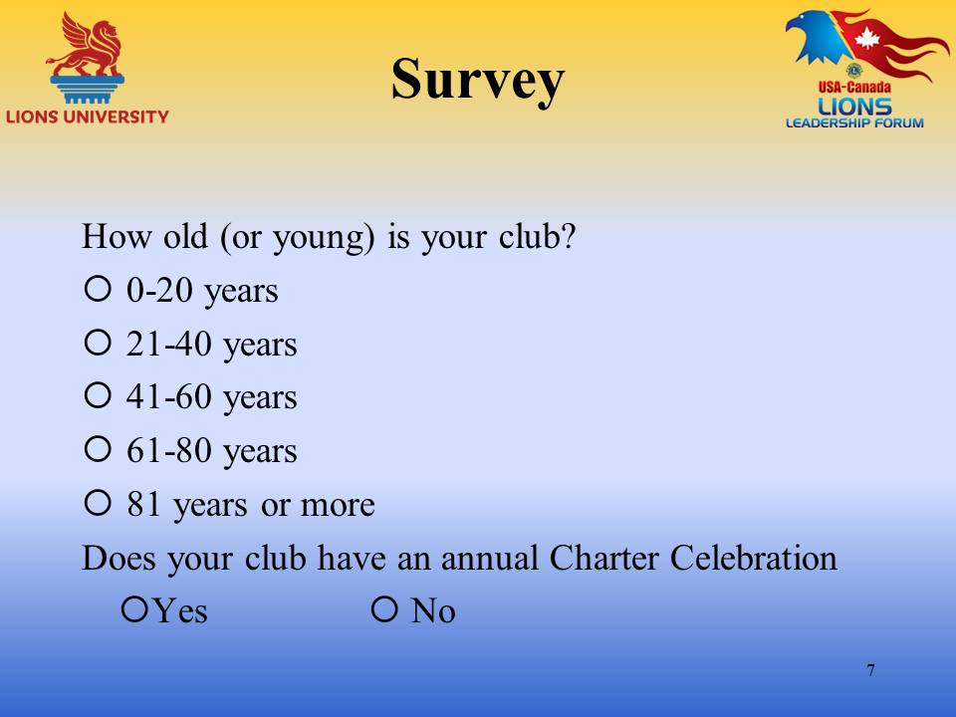 | Survey:  How old (or young is your club? Choose one among the 20-year intervals  Does your club have an annual Charter Celebration? Answer yes or no. Thank you for participating in this survey.
Slide 8  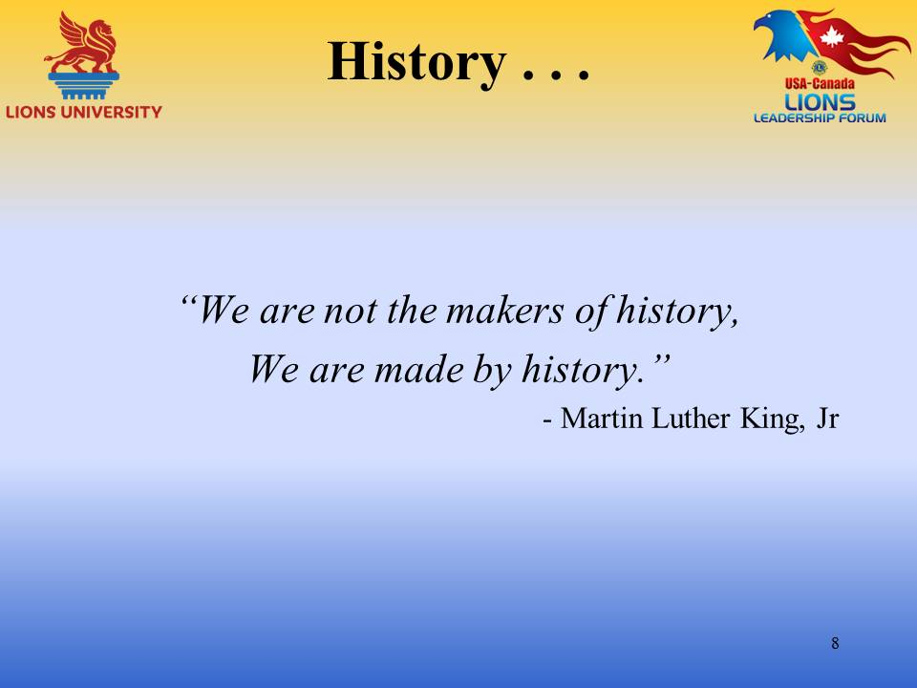 | “We are not the makers of history, We are made by history.” – Martin Luther King, Jr.
Slide 9  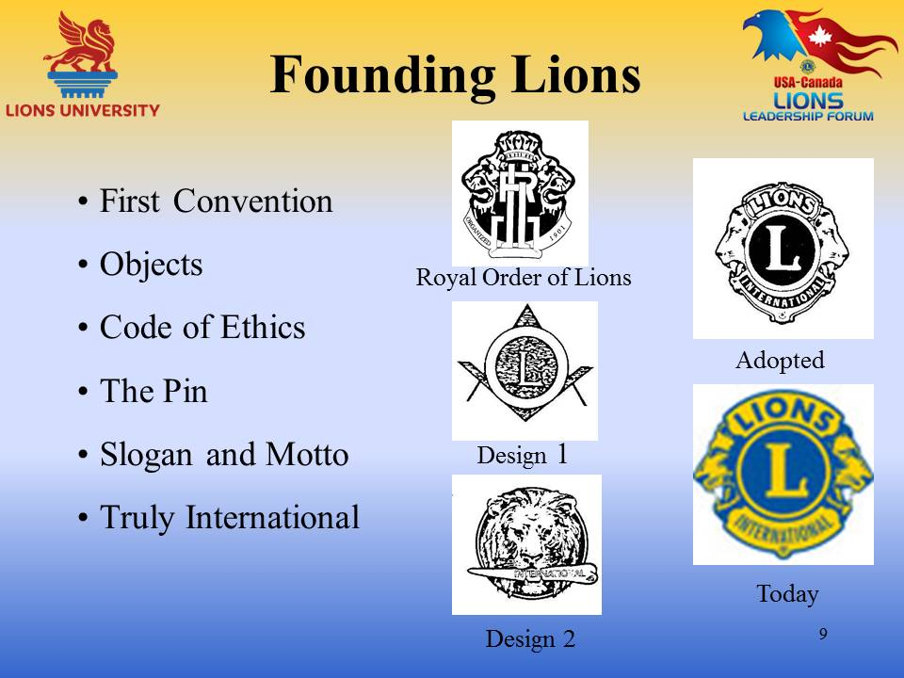 | Founding Lions  First Convention – Dr. W. P. Woods called the first annual convention for October 8-10, 1917 at the Adolphus Hotel in Dallas, Texas. Dr. Woods was elected President and Melvin Jones was appointed Secretary. A Constitution and By-Laws were adopted, colors were agreed upon and the Lions Objects and Code of Ethics were drafted. Texts of the Objects and the Code of Ethics as they were first proposed and as they exist today are included in the handout materials.  Objects – Years after the Objects had been adopted Melvin Jones said: “If a Lions club follows out its Objects, it will have the full program. It will be interested in world affairs, in national problems in the needs of its own local community and in the welfare of individual members.”  Code of Ethics – Legend has it that Melvin Jones made an exhaustive study of every code found in history. He studied the thoughts of Hammurabi of Babylon, the Napoleonic Code, the Mosaic Commandments, the Justinian Codex and he noted one feature they had in common. They were all filled with negative commands. He said that that was not what the Lions were looking for and that what we finally got was a ‘leadership code’ and that there was not a single ‘Thou shalt not … in it.’  The Pin – The Lions logo which is the basis for our pin was approved in December of 1921. It was created by merging two other designs that had been presented. The L and circle from Design 1 formed the center with 2 Lions heads from Design 2 with the word Lions on the top and International on the bottom. The Lions are facing our proud past and bright future. Today’s pin is represented as the fourth picture.  The Slogan – Liberty, Intelligence, Our Nations Safety. Chosen at the third international convention (Chicago, 1919); this slogan represented the patriotism alive during the First and Second World Wars. It still is appropriate nearly 100 years later when terrorism abounds in our world and distrust among people reaches new heights at the same time that service to those in need is also achieving unimagined levels.  The Motto - We Serve. At the International Convention in 1954 this simple phrase, submitted by Lion D. A. Stevenson, was chosen from more than 6000 suggested mottos. It symbolizes the moving spirit of Lionism: to help others and to tear away the shrouds of ignorance and distrust that separate one human being from another.  Truly International – It was in 1920 that Lions Clubs International became truly international in fact as well as in principle. In that year a Lions Club was formed in Windsor, Ontario, Canada. The third, fourth and fifth countries to have Lions clubs were China, Mexico and Cuba in 1926 and 1927.
Slide 10  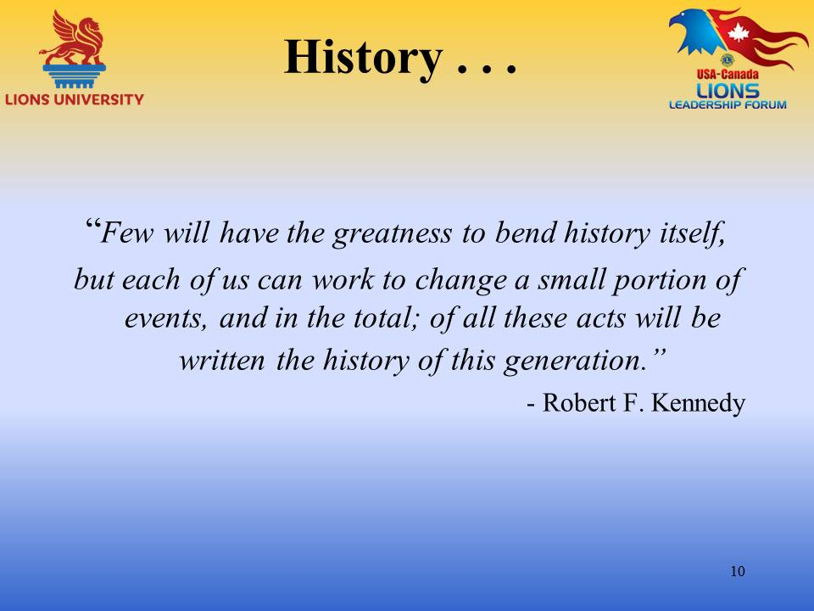 | “Few will have the greatness to bend history itself, but each of us can work to change a small portion of events, and in the total; of all these acts will be written the history of this generation.: - Robert F Kennedy
Slide 11  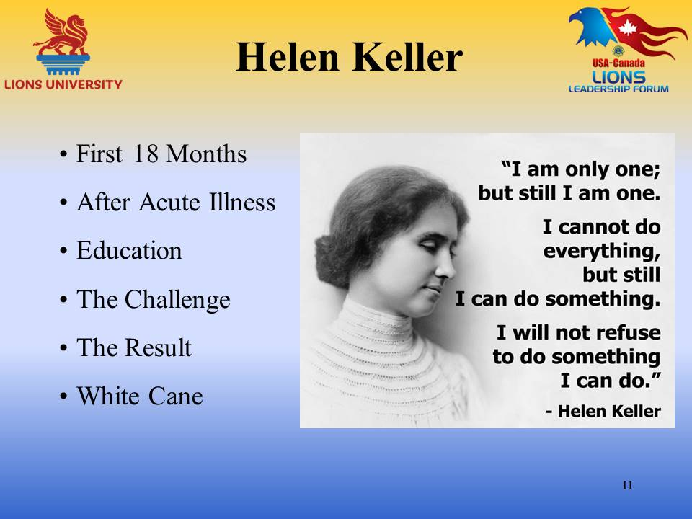  Slide 11 (Continued) | Helen Keller  First 18 Months – Helen Keller was born in 1880 to well-to-do parents. Her father was a former officer in the Confederate Army and her mother was related to Robert E Lee. She was an unusually bright child. When she was 18 months old she became acutely ill with what was diagnosed as congestion of the brain and the stomach.  After Acute Illness – After her illness young Helen was left with neither sight nor hearing. She forgot the words she knew and became speechless. She was a troubled child who became troublesome. She would become angry when her parents or care givers were not able to understand her signs. She would lash out with kicks screams and tantrums. Her doctor believed that her intelligence could be developed if she could be taught to communicate. They contacted Alexander Graham Bell who had been teaching deaf children and he suggested that they hire a teacher from Perkins Institution for the Blind. Nineteen year old Anne Sullivan was recommended and hired.  Education - Following her personal tutoring by Anne Sullivan, Helen attended Horace Mann School for the Deaf, Wright Humason School for the Deaf, Cambridge School for Young Ladies and at the age of 24, graduated from Radcliffe College. In these endeavors she was accompanied by Anne Sullivan.  The Challenge – After graduation from college, Helen Keller was an activist for many causes, not all of them popular. The important cause in the course of Lions history was her work for the American Foundation for the Blind. The International Association of Lions Clubs invited Helen Keller to speak at the ninth annual Convention held in Cedar Point, Ohio in 1925. She accepted the invitation and with Anne Sullivan’s assistance made the speech that would define the course of Service for Lions Clubs into the 21st century. The final paragraph of that 500 word speech was: “The opportunity I bring you, Lions, is this: To foster and sponsor the work of the American Foundation for the Blind. Will you not help me hasten the day when there shall be no preventable blindness; no little deaf, blind child untaught; no blind man or woman unaided? I appeal to you Lions, you who have your sight, your hearing, you who are strong and brave and kind. Will you not constitute yourselves Knights of the Blind in this crusade against darkness? I thank you.” The Lions applauded wildly. A motion was made to make Helen Keller an honorary member. It was seconded exactly 100 times. The same honor was accorded to Anne Sullivan.  The Result - Before the delegates left the convention they voted to adopt sight conservation and work for the blind as a major service activity for the association. From Kid Sight screenings, to cataract surgeries to research the Lions have accepted and continue to accept the challenge to be Knights of the Blind and the world is better off because of that.  White Cane – In 1930 Lions work with the blind was in its early stages, but Lions clubs were already emphasizing ways to help prevent blindness and were actively promoting services for the blind. The president of the Peoria Lions club saw a problem and developed a solution that spread throughout the world. Lion George Bonham saw a blind man trying to cross a busy street as traffic whirled around him. The man tapped furiously on the pavement with his black cane but no one understood the problem. Lion Bonham came up with the idea of supplying people with white canes to alert others and he introduced a resolution to the city of Peoria to give the right-of-way to any blind person using a white cane. By 1956 every state in the United States had passed white cane safety laws which also included blind persons with guide dogs. This is only one of the innovative ways that Lions have accepted the challenge to be knights of the blind.
Slide 12  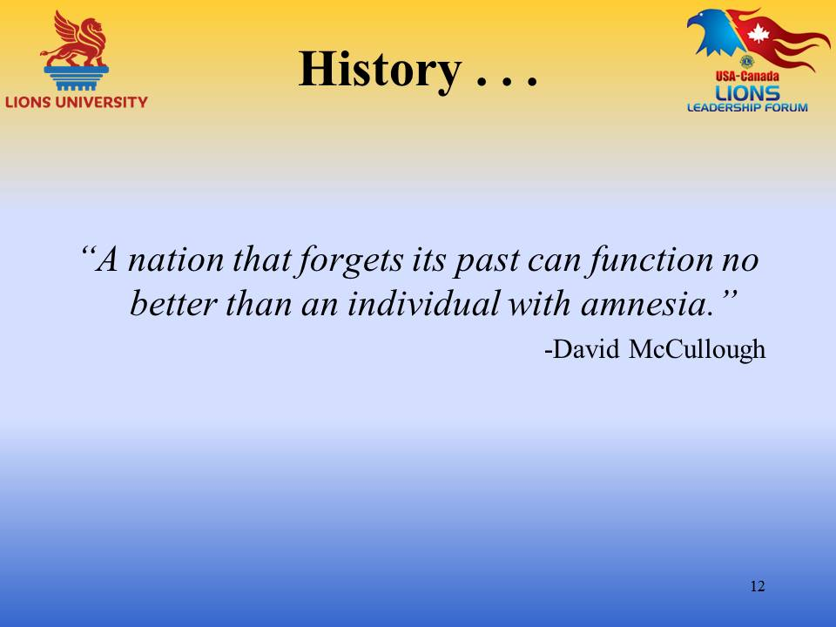 | “A nation that forgets its past can function no better than an individual with amnesia” –David McCullough
Slide 13 | Lions and the UN  The Invitation – In 1944 President Harry Truman invited Lions Clubs International to participate in the discussions that led to the chartering of the UN. The Lions and several other similar organizations of like mind were asked to help in writing the nongovernmental portion of the UN Charter. Lions participated in the Dumbarton Oaks Conference, the Bretton Woods Conference and finally the San Francisco Conference at which time the UN Charter was actually drawn.  Relationship Continues – Lions Clubs International is affiliated with UN agencies that provide assistance worldwide to people in need. These agencies include UNICEF, the World Health Organization, the Food and Agriculture Organization and the UN Committee on Narcotics and Substance Abuse.  Lions Day with the UN – Lions Day with the United Nations began in New York in 1958. It now has about 700 attendees from the United States and other countries and is also held in other cities around the world. The Peace Poster winner award is generally presented at this function.
Slide 14 | “Never doubt that you can change history, you already have.” – Marge Piercy
Slide 15  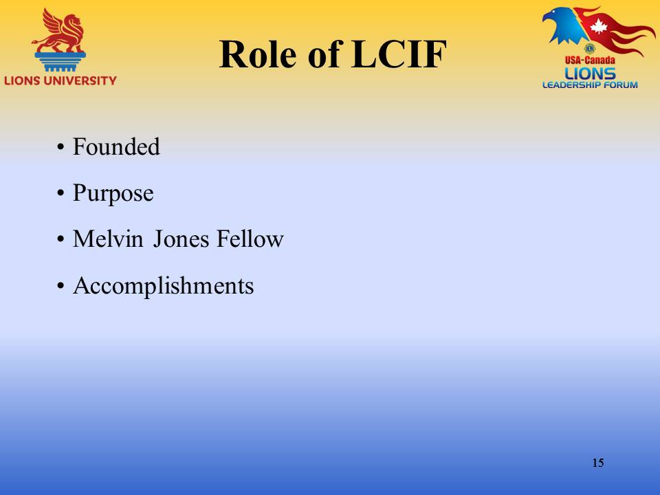 | Role of LCIF – Lions Clubs International Foundation is the charitable arm of our association.  Founded – LCIF was begun in 1968 to take our service to new levels by tackling global problems as well as assisting Lions with local humanitarian projects too big to do on their own.  Purpose - LCIF helps Lions improve peoples’ lives around the world, from combating vision problems to responding to major catastrophes to valuable life skills to youth. Because LCIF helps Lions carry out large-scale projects through the grant programs, Lions increase their impact in their local and global communities and serve even more people in need around the world.  Melvin Jones Fellow – In 1973 the foundation’s highest honor was created and the Progressive Melvin Jones Fellowship was added in 1986. The Melvin Jones Fellowship is the backbone of LCIF, providing 75% of its revenues.  Accomplishments – The first grant awarded by LCIF, in 1872, was $5,000 for flooding in South Dakota. The first Major Catastrophe Grant, in 1985, was for $50,000 for earthquake relief in Mexico. Please see the Handouts for a summary of the major accomplishments of LCIF.
Slide 16  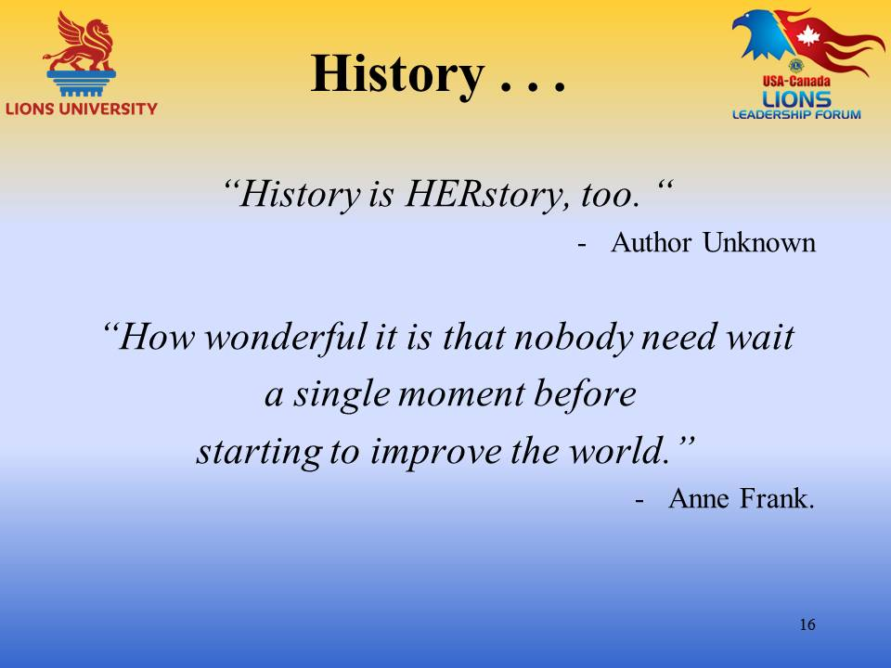 | “History is HERstory, too.” – Author Unknown “How wonderful it is that nobody need wait a single moment before starting to improve the world.” - Anne Frank
Slide 17  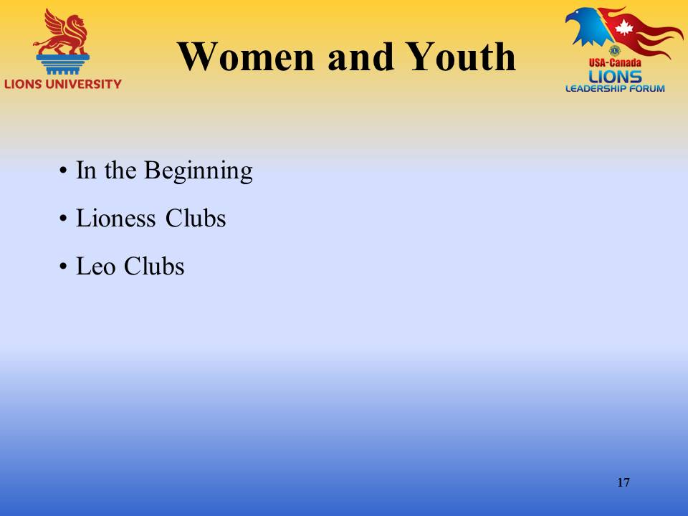 | Women and Youth  In the Beginning – During the first year women were not excluded from membership in Lions clubs, however at the second annual convention it was decided to exclude women from membership. This policy remained in place until 1987 when Lions Clubs International was the first major service organization to invite women members. Since 1987 women’s membership has grown to or % of our membership. Women are active not just on the club level but also on the district and international levels too.  Lioness Clubs – The March 1920 issue of The Lion described the formation of the first wives’ club. It was called the Lioness Club of Quincy Illinois. It was organized “for the express purpose of being a helpmate organization to the Lions and Quincy.” The Lioness movement spread throughout Lionism and peaked in 1987 with 157,000 members. In 1992 LCI discontinued the support for Lioness clubs, but they still may exist as a project of a Lions Club. Lioness clubs were also invited to convert to Lions clubs with the option of keeping the word Lioness in their name to honor their history and heritage.  Leo Clubs – The Glenside (PA) Lions Club chartered the first Leo Club in December 1957. Junior service clubs were chartered by other service organizations also. Ten years later the International Board of Directors of Lions Clubs adopted the Leo Club Program as an official program of the association. Leo Clubs are open to both males and females. The objective of the Leo Club Program was and still is; “to provide the youth of the world with an opportunity for development and contribution, individually and collectively, as responsible members of the local, national and international community.”
Slide 18  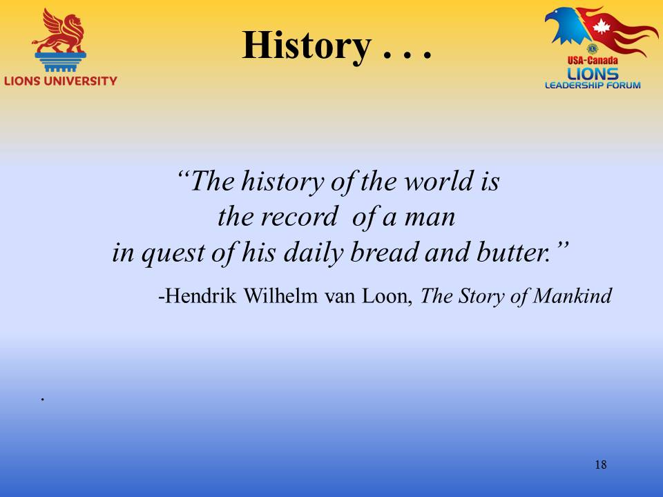 | “The history of the world is the record of a man in quest of his daily bread and butter.” -Hendrik Wilhelm van Loon, The Story of Mankind.
Slide 19  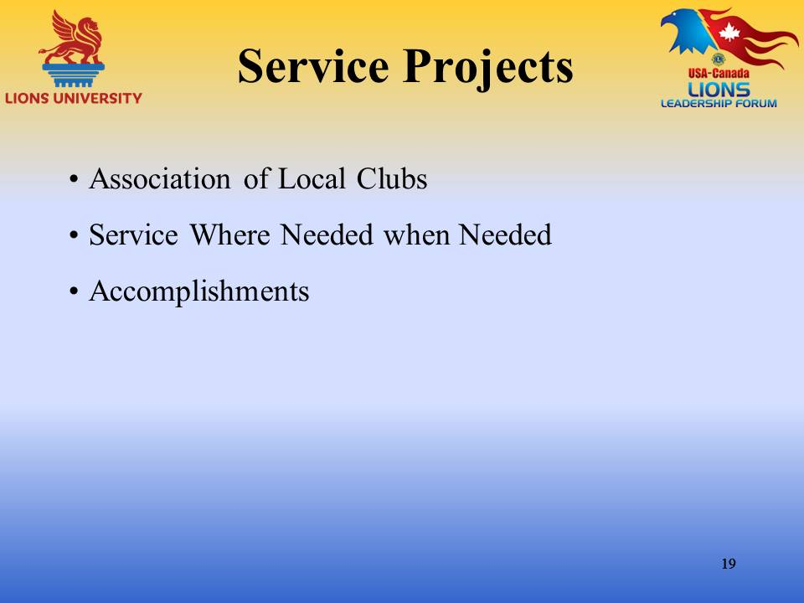 | Service Projects  Association of Local Clubs – The history of Lions Clubs International is a history of an association of local clubs from all parts of the globe working for the betterment of their communities.  Service Where Needed When Needed – Our unique structure has provided immediate response from local Lions when there is a local need as well as the support from our international foundation for projects that are too large for the local group to accomplish. I am sure that many of you have seen the immediate response of aid when natural disasters such as floods, hurricanes or tornadoes have devastated communities. The local Lions are there immediately. Emergency grants from LCIF arrive in a matter of days not weeks.  Accomplishments – Some of accomplishments of the past hundred years have been described in local media. The scholarships awarded, the parks cleaned, the holiday displays put up and taken down annually, the trees planted and the books read to school children. Many of the other services have been just between the Lions and the recipients – and those are often the ones that touch the hearts of Lions and kindle the fires to keep them doing what they do. The child who has been provided with glasses that his/her family cannot afford, the groceries that are delivered to parents who are unable to provide for their families, the food baskets that are delivered to shut-ins during the holiday season and the gifts that are lovingly wrapped for children we don’t know so that Santa will have left something under the tree that was probably also donated by the Lions. In all of the books listed as resources there are hundreds of stories of individual service by Lions and their clubs. There is also a list of some of the service projects that have been done.
Slide 20  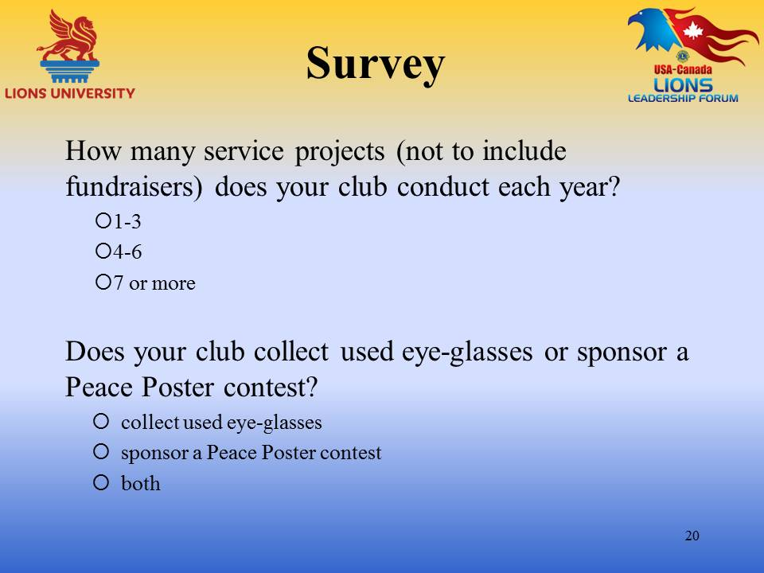 | Survey  How many service projects (not to include fund raisers) does your club conduct each year? Please mark the correct interval.  Does your club sponsor a Peace Poster? Please mark yes or no.  Does your club collect used eyeglasses? Please mark yes or no and submit your data to be tabulated.
Slide 21 | History is a novel for which the people is the author.” –Alfred de Vigny, Reflexions sur la Verite dans l"Art
Slide 22  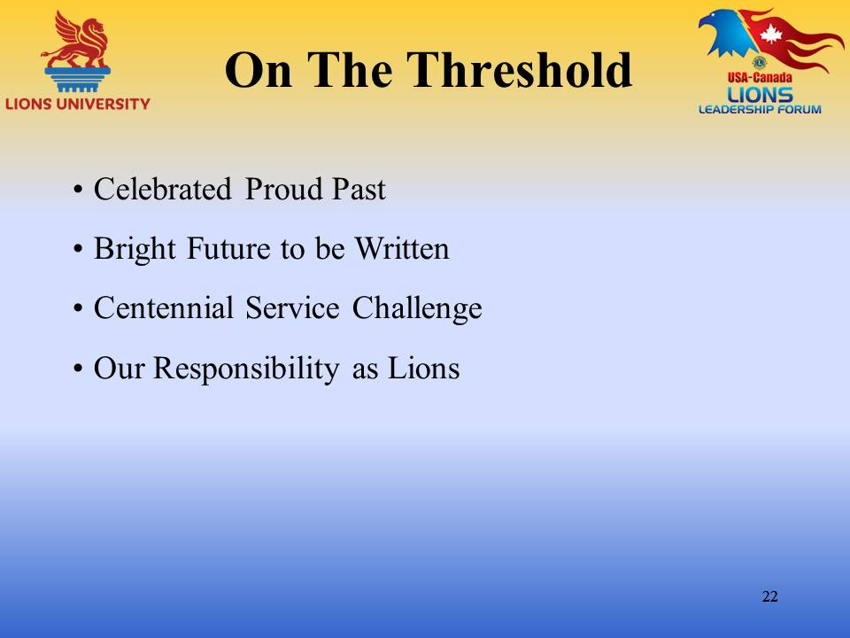 | On the Threshold – As Lions stand on the threshold of their second century it is time to evaluate what we are doing, making sure that we are relevant to our communities and their needs. We must also be sure we are relevant to our members without whom we would be unable to fulfill our pledge of service to those in need.  Celebrate Proud Past – The accomplishments of the past 100 years provide many opportunities to celebrate, and celebrate we should.  Bright Future to be Written – But Lions don’t live on their laurels they are always looking for more ways to help more people and communities in need.  Centennial Service Challenge – A good start is for each club to participate in the Centennial Service Challenge of serving 100,000,000 million people by the end of June, 2018. Using the Global Service Projects of Engaging our Youth, Sharing the Vision, Relieving the Hunger and Protecting our Environment. See the LCI website for suggestions of projects that you might be interested doing.  Our Responsibility as Lions – I wanted to say something profound about our responsibility as Lions as we face the challenges of the future. I discovered, however that it had already been said.
Slide 23  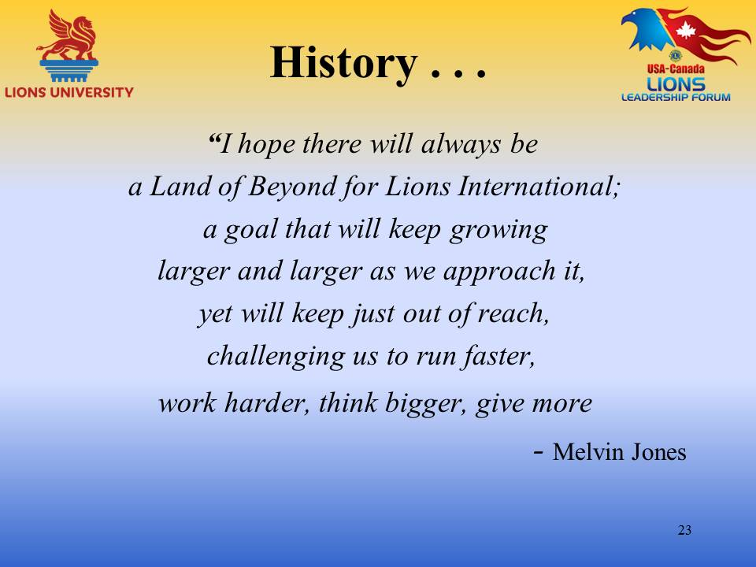 | “I hope there will always be a Land of Beyond for Lions International; a goal that will keep growing larger and larger as we approach it, yet will keep just out of reach, challenging us to run faster, work harder, think bigger, give more – Melvin Jones
Slide 24  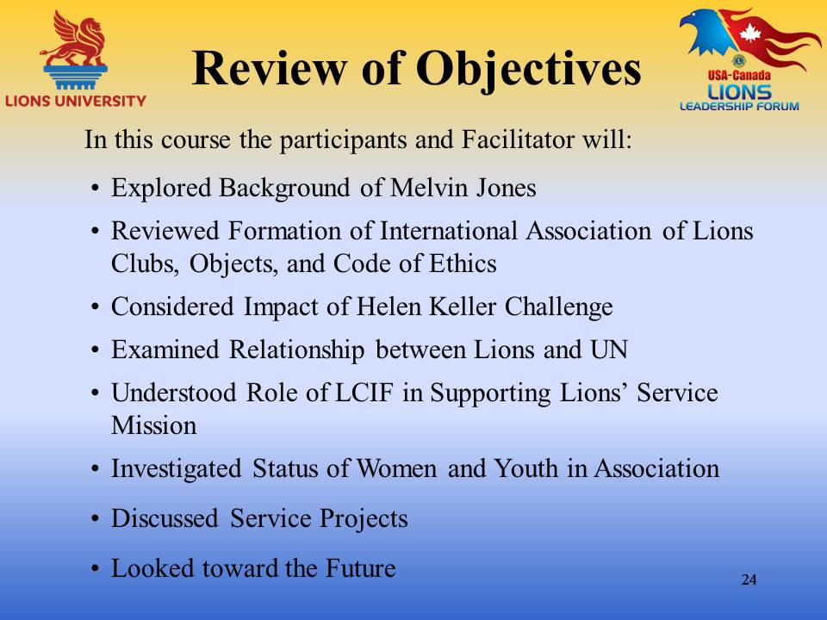 | Review of Objectives  - Explore Background of Melvin Jones  - Review Formation of International Association of Lions Clubs, Objects, and Code of Ethics  - Consider Impact of Helen Keller Challenge  - Examine Relationship between Lions and UN  - Understand Role of LCIF in Supporting Lions’ Service Mission  - Investigate Status of Women and Youth in Association  - Discuss Service Projects  - Look toward the Future
Slide 25  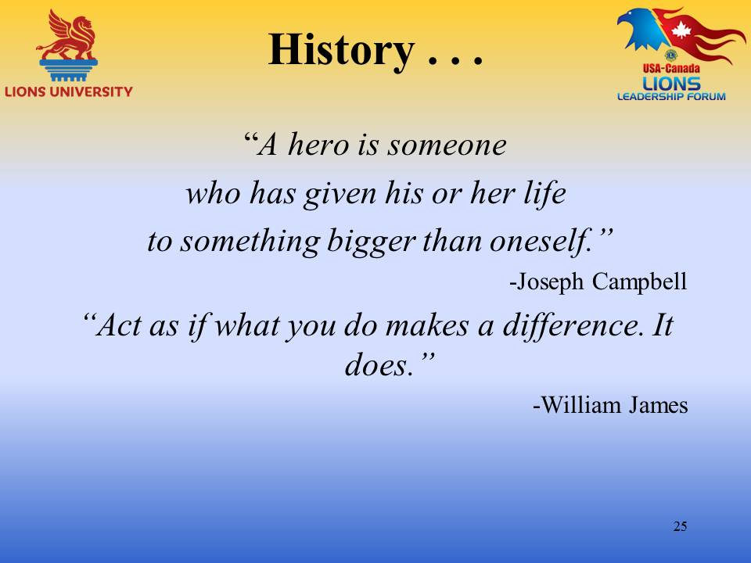 | A hero is someone who has given his or her life to something bigger than oneself” –Joseph Campbell Act as if what you do makes a difference. It does..” – William James
Slide 26
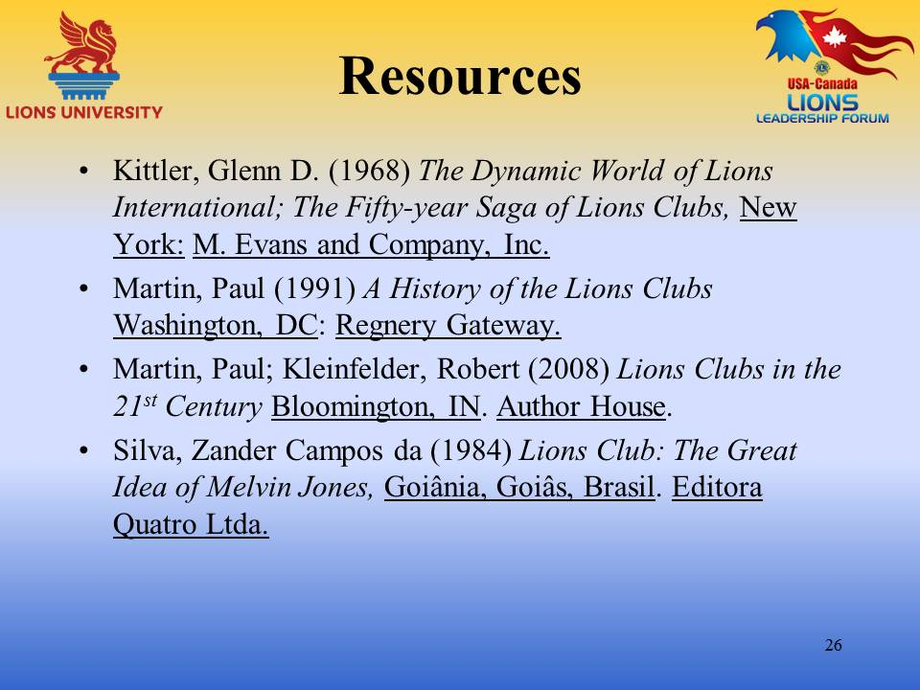

Slide 27 | This ends our course on Lions History!  We hope you have enjoyed the interaction, and are able to take away some important and useful ideas!  In order to get credit for this course through Lions University, you will need to register for an account and/or login to http://www.LionsUniversity.org/  Navigate to the Bachelor Program listing and this course. After participating in a live course, select “Mark as Completed” and the quiz module will be made available.  You are able to track your course completion progress real time.  You can utilize any of the notes, information and materials from this webinar. Good Luck!
Slide 28  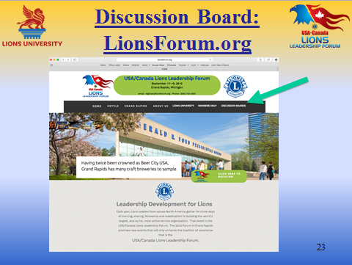 | You can also participate in the discussion about this topic or other Lions University course topics by going to the http://LionsForum.org web site.

