Slide 1  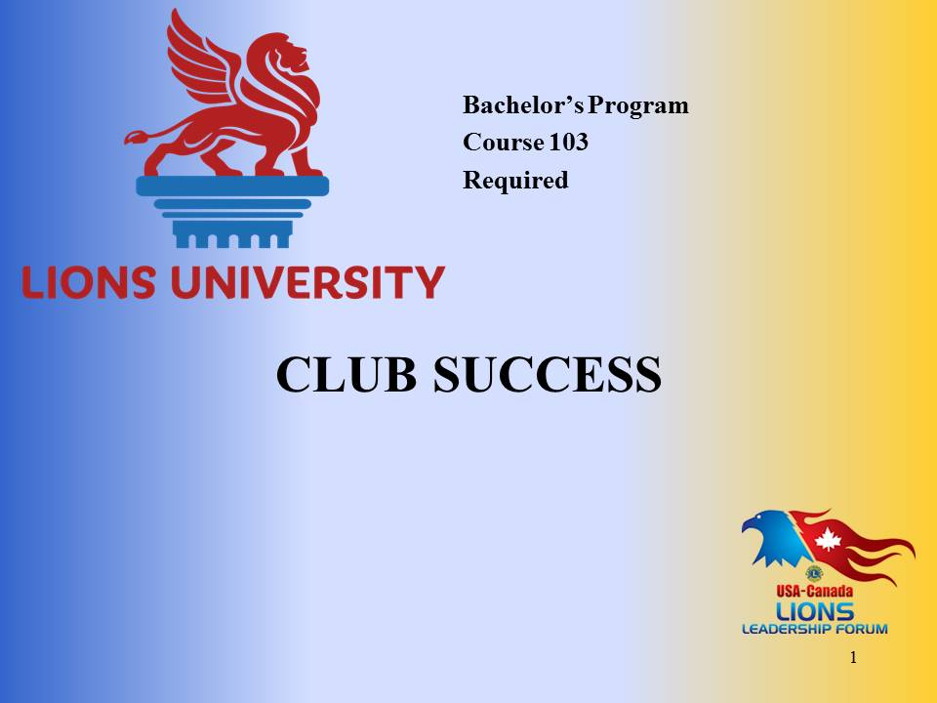 | Welcome to Club Success.  This course content was prepared by PDG Marcia Newyear from District 46, Nevada for Lions University and the USA/Canada Lions Leadership Forum.  This material has been made available for District and Multiple District leadership development.  You will be able to get credit for participating in this live seminar through Lions University by later taking an online quiz.
Slide 2  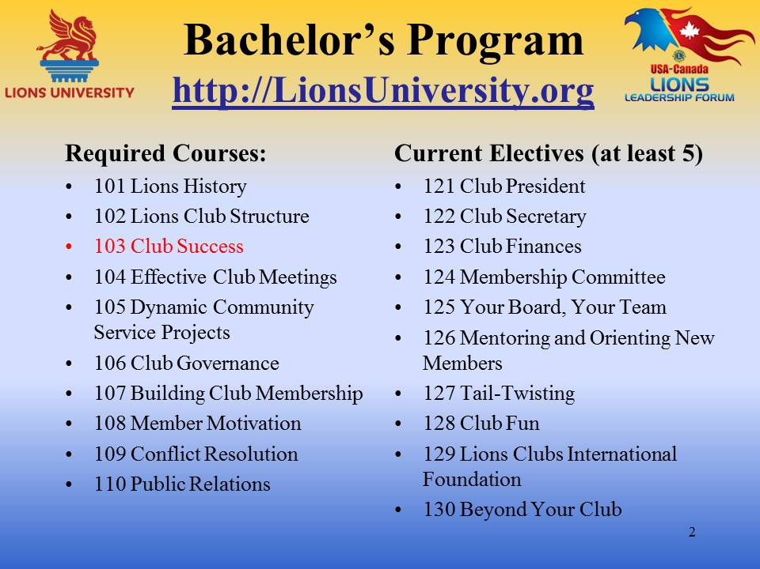 | Club Success is course #103, a required course for the Lions University Bachelor’s Program that is designed to help Lions lead at the club level.  The Bachelor’s Program involves the completion of ten required courses and at least five elective courses.
Slide 3  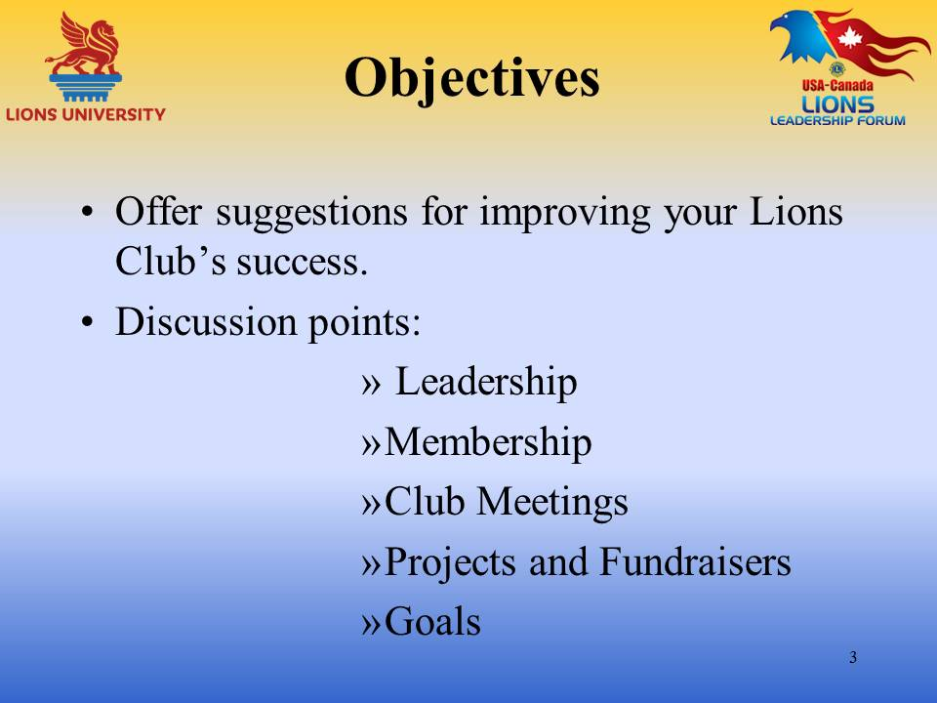 | Just as with humans, there are no two Lions clubs anywhere that are the same. That’s what makes our life so much fun…sometimes.  To be a successful club takes more than one webinar and what I tell you may seem obvious to some Lions that have “been there – done that”. Hopefully there will be some new ideas that you will be able to use. For new Lions members, congratulations on wanting to step up and help your club to greater success by getting involved.  I like to think of Lions clubs as a business. We are in the business of “Service”. The President is the CEO….VPs…etc.  The person and business that I would like you to use as an example is Walt Disney, the person that created the “Happiest Place on Earth”. How did he create a business so large and still going so strong today? Well, he was a man that had a vision, set goals, listened and honored his employees. People have been devoted to Disney for years. Even after he is no longer with us he still lives on.  One well known quote by Walt Disney is, “If you can dream it, you can do it”.  So, how does that have anything to do with Lions? With our Service, we are creating the “Happiest Earth”. In order to do this we have to pursue Club Success. So the objectives to “Club Success” that we will be discussing are:  - Leadership  - Membership  - Club Meetings  - Projects and Fundraisers  - Goals
Slide 4  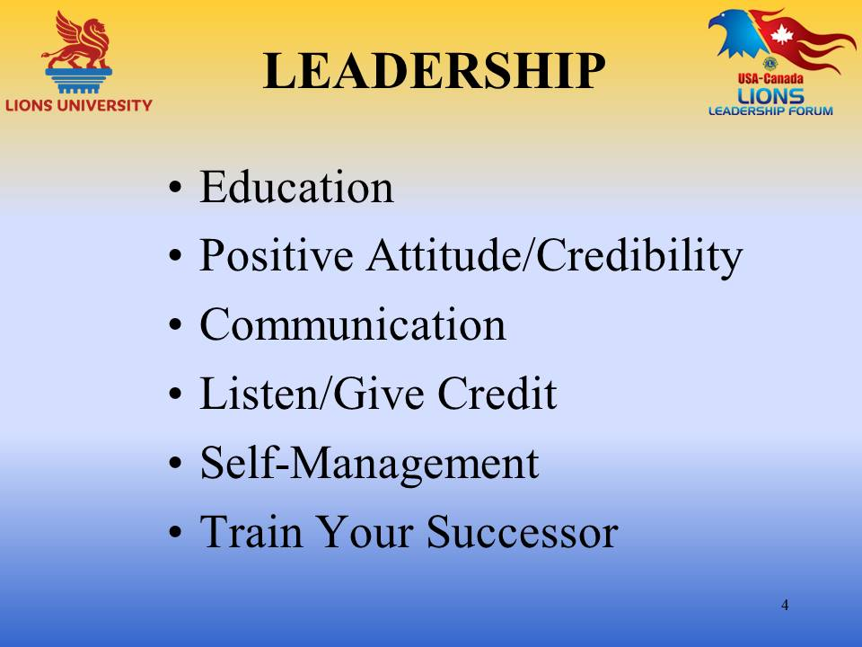 | It is all about the Club President. The more educated the President is, the better prepared he/she will be (even for those that have been President before). Education should never stop.  There are so many classes available for education now and if you are taking this webinar, you already know. Lions University has many wonderful webinars, LCI has webinars plus classes on line, the Faculty Development from LCI, Regional leadership training and of course the very best is USA/Canada Forums.  The club president must be able to maintain a positive attitude and credibility.  - They reconcile frustration, confusion and uncertainty  - They know the value of a compromise; there are no “winners” and “losers”.  - They are the first to reach out.  - They bring out the best in everyone.  - They bring into harmony all the varied interest of his members.  - Delegation gives a balance between management and getting things done.  The President always keeps open communication with the club members.  - A Lion leader clearly communicates procedures in areas of responsibility.  - They make sure accomplishments of the club are brought to the attention of the community.  - They know what needs to be done, how it is to be done and who is going to do it.
Continued from previous page | LISTEN AND GIVE CREDIT  A Lion President is always there to listen and most of all give credit. A President can’t do that enough. When presenting an award, pin or big handshake make sure the club is aware of what the presentation is about. Make sure pictures are taken.  The President of my club was given 12 buttons to give to “volunteer of the month” at her installation. This has been a big hit and well deserved for all that have received them.  Listening also takes in conflict, which also needs to be handled by the President. Please make sure all conflicts are handled behind closed doors not at a club meeting.  SELF MANAGEMENT  - Lion Leaders are course changers and pathfinders.  - They set goals and motivates their fellow Lions to reach them.  It is very important is to train your successor. Make sure your club has at least 1st Vice President and keep them always in the loop. This is not only important for the President, but also the Secretary and Treasurer. So many people end up being President, Secretary, and Treasurer for years just because no one else can take on that job or want to.  A leader’s job is to look into the future of the club and see not as it is, but as it should be!!!  A good leader needs enthusiasm and passion.  Henry Ford said, “Enthusiasm – with it there is accomplishment – without it there are only excuses – set an example for others to follow.”  If the Club President has done his job well, his fellow Lions can say, “We did it ourselves”.  [Get input on other areas from participants]
Slide 5 – on Next Page | Communication –Keep everyone in the loop as to the action of the club. Verbally by telephone, or by email, have a club newsletter, and websites…use all. Have a phone tree. Make sure everyone is coming to the meeting and if someone is sick and might need some help let the Lions know.  Appoint a sunshine or public relations person. Your Sunshine person’s job is to keep in touch with the club members, acknowledging milestones like birthdays and anniversaries. Public Relations person should be willing to let the world know all the important work the club is doing. Making close friends of the local newspaper editor or the local radio station broadcaster is important.  Image – A good image in a club not only makes the club members feel good, but also makes a good impression in the community where the club is serving. Think how you feel when you first walk into the gates of Disneyland….the energy, the floral display, the anticipation, the parade, the employees are in great uniforms and are having a good time and they want you to have a good time. When you think of your club meeting do you get that same feeling when you walk in? Ask yourself this, “If I were a prospective member, would I want to join my club?”  Good Attitude – a no negative attitude will keep the club growing. Our work as Lions is easy as long as it is fun.  There is a club in California that always wore a “No Negative” button. A great reminder…  Clubs that have “Lions night out” can be beneficial. Plan a night out for dinner that is someplace other than your meeting place. Or plan to all go see a movie, play or performance as a group. It can be a nice bonding experience.  A club in my District has game nights where they each take turns hosting the game. The game is up to the host. This has been a good tradition for this club.  New member committee – Membership is EVERYONES responsibility and in most clubs this is a one person job the membership chair, but it is a much more important job that most people realize or want to admit. The job should entail not only finding new members, but keeping the current members. There should be an orientation for current and new members. This job should be handled by a committee if at all possible. New members should have a mentor and all new members should have a job.  - Create a club brochure  - Create business cards as an invitation to meetings  - Create a new member handbook  - Always have membership applications on hand  If your club has not done the CEP (Club Excellence Process) training, please ask your District Global Membership chair. Having an officer that is not part of the club do the CEP training can be an asset. It is possible that little problems will surface that can be cleared up way before they become volcanoes.  Make sure at least one member attends District functions. There is a lot to learn at these meetings even from members from other clubs. I’ve learned as much during meal breaks from Lions from other clubs and Districts as I have from seminars I have attended.  Each club should have membership goals. Gives members something to work toward. Have membership contests.  Have at least one open house or Friendship dinner a year and make sure all members invite someone. This works!  No matter how great or how large your club is at the present, if membership is not maintained, “The Empire could fall”.  A friend was telling me about his club of 23 members, 8 of which come to the meetings and he is the President, Treasurer and the Secretary……….Lions clubs don’t die, they commit suicide.
Slide 5
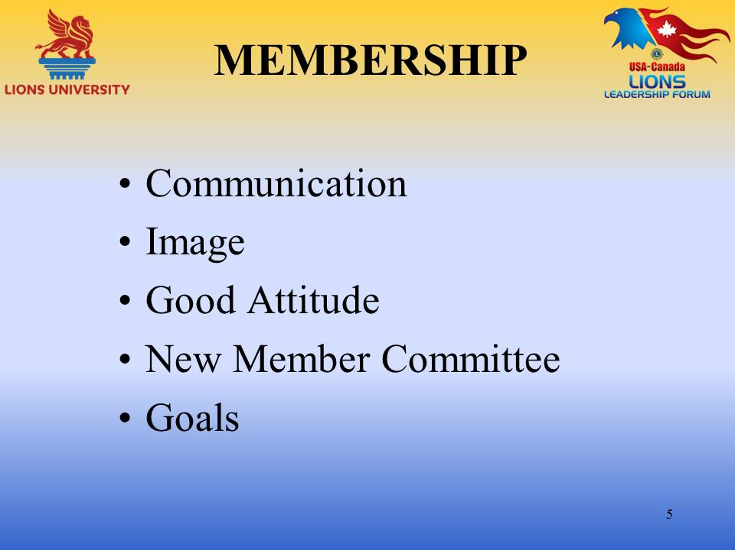

Slide 5 (Continued)
Slide 6 | [Get input on other areas from participants]
Slide 7  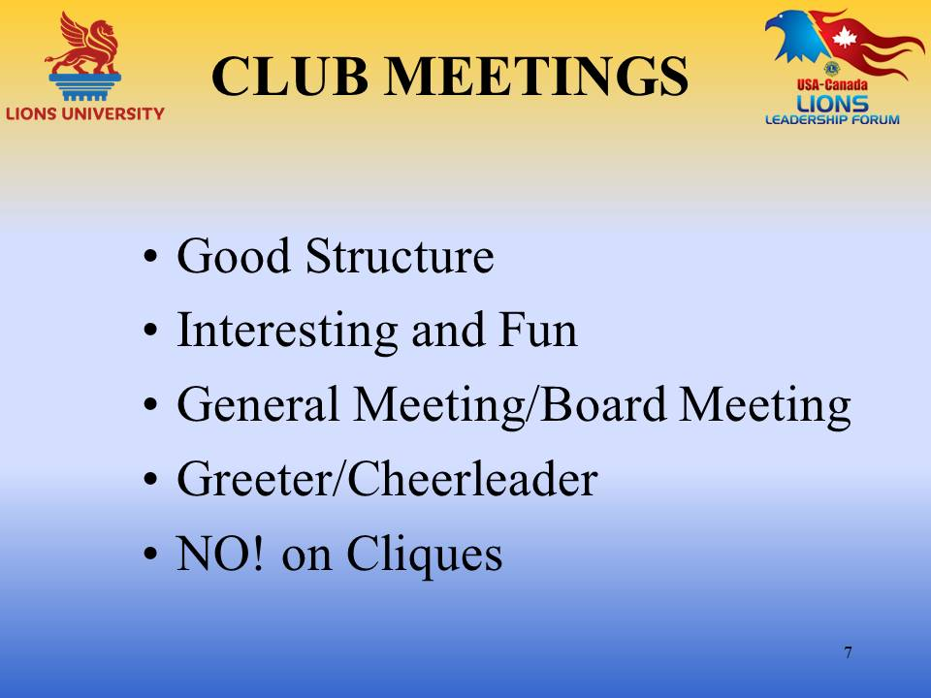  Slide 7 (Continued) | Maintaining good structure – always have an agenda and follow it. Stick to the time so it does not run over.  Make your club meetings interesting and fun. In Corporate businesses, the officers will hold meetings and then let the employees know what was discussed. This should be the same with Lions business. Try to keep business to a minimum during the general meetings. Have quick committee reports so the members are aware of their progress but not take over the meetings.  Have one minute of Lionism at every meeting. Such as one minute about Melvin Jones, about the History of Lions, about our mission. Loads of information to share if you go to LCI’s web page.  Find informative speakers. There are really great speakers everywhere… (Metal detector)  Avoid people that are trying to sell something because your club will lose.  Hold impressive Induction ceremonies. You want your new members to feel welcome and the club is there with open arms and a helpful hand to greet them. Have an officer from outside the club such as a District Officer. Make your new member feel that they are very important to your club. I always feel it is real important for the club members to greet the new members after the induction.  Having a good Tail-twister is an advantage. Someone who can think “What would Disney do?” Be creative and fun. Send your Tail-twister to USA/Canada Forum. There is usually someone doing a seminar on Tail-twisting.  - Get some ideas from the internet or talk to the local scout master.  - Secret Greeter  - Happy bucks - Birthdays/special occasions - Lion member in the news  - Games/Trivia words  - Rolling dice – people that have grand news and want to share/pay to do so/roll the dice. If the dice comes up 7 or 11 then all the members have to come up with a dollar. Only once an evening.  Tail-twisters - DO NOT INTERRUPT THE MEETING  Always have a “Greeter”. If at all possible, make it a different Lion every meeting. This gives all members a chance to meet and greet before the meeting. Try to have people sit with different people at every meeting.  Absolutely “NO on Cliques”. A club’s membership should be able to work as a team and act like a family. Cliques create gossip and hard feelings.  [Get input on other areas from participants]
Slide 8  Slide image on next page  Slide 8 | Be prepared…Brainstorm at the first of the Lions year and set schedule. Have a club retreat. “Get away for a day and plan”.  Begin a new club project every year. Get the new members involved. Use their ideas and suggest the chair the event.  Replace a project that hasn’t been working or add a new one to your Lions list.  Centennial Service Challenge. International would like to have served 100 million people by the Lions Centennial year 2017. So they have asked each club to do at least four areas of service each year. If clubs would just follow the lead, it is so simple and gives you a guide for your club. A suggestion - Create a different service for each quarter of your Lions year…..the four service projects are:  Vision – Youth – Feeding the Hungry – Environment  - Vision – most clubs collect eye glasses, have the ability to do vision screening, sponsor a guide dog or buy a pair of glasses for a needy person.  - Youth – Leos clubs, read to a class for Read across America, or present flag day to a school class.  - Feeding the Hungry – Help at a soup kitchen, Christmas or Thanksgiving Baskets, or sponsor a family in need.  - Environment – Plant trees, clean a park or sponsor a section of highway, or start a community garden (which would help feed the hungry).  LCI has suggestions on their website for each of the different projects that would help plan your club projects.  Fundraisers – Important to have a Fundraiser chairperson, a treasurer and then committee. The chairperson should be willing to delegate, keep tabs on progress and making sure everyone has completed their tasks. All fundraisers that entail the public, proceeds need to go into the Charity account and cannot be used for the Administrative Account.  To boost your clubs Administrative Account, having an “in-house” auction can be a lot of fun. Members bring goods and services to a designated meeting and the auctioneer determines if the items are silent bids or he/she will auction the higher end items. Since the money is all from the Lions, it can be used for administrative account.  [Get input on other areas from participants]
Slide 9  Slide image on next page  Slide 9  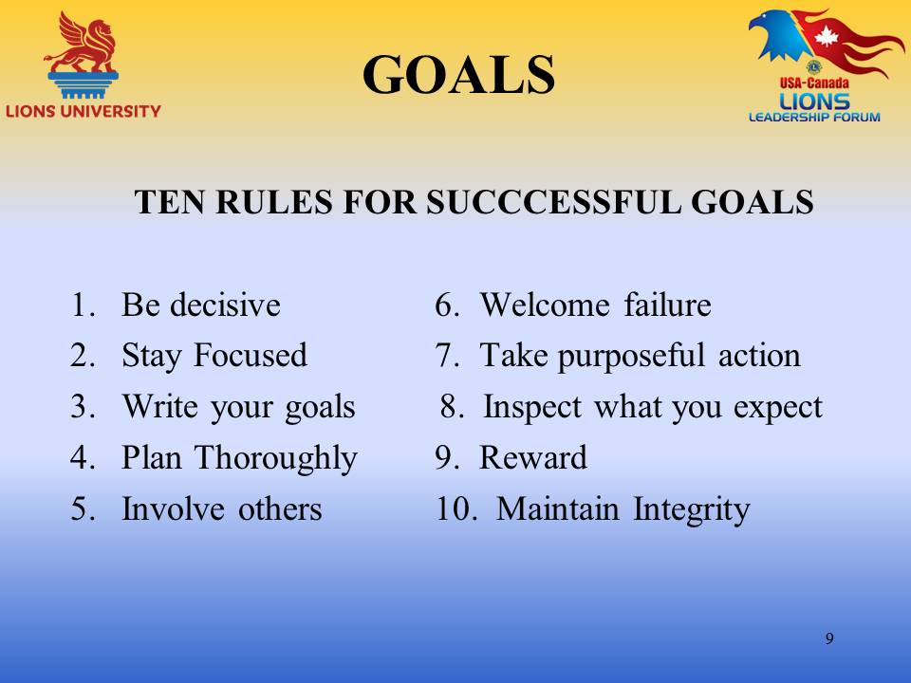 | Goals being one of my big weaknesses, I turned to a book I like written by Gary Ryan Blair called…of all things…..GOALS.  He has ten very wonderful rules to accomplishing GOALS and I’m sure he used them to write this book.  - BE DECISIVE – Indecision is the biggest eraser of opportunity and potential.  - STAY FOCUSED – Focus is the glue that holds the goal in place. Without focus you lose your way – enthusiasm disappears – goals become faded aspirations.  - WRITE YOUR GOALS – written goals are catalysts, transforming agents for success and achievement. Goals not written become “out of Sight – out of mind”. Six important goal setting questions:  - WHO – will be involved in achieving this goal?  - WHAT – is the goal? What to accomplish.  - WHERE – are you now in relation to this goal?  - WHEN – do you expect to achieve this goal?  - HOW – will you accomplish this goal?  - WHY – do you want to achieve this goal?  - PLAN THOROUGHLY – planning allows you to carefully orchestrate all steps along the way to achieve your goal.  - Coordinates efforts  - Prepares the planner  - Reveals roadblocks  - Stimulates thinking  - INVOLVE OTHERS – History repeats itself – with the use of the internet and all resources, there are teachers everywhere. It is your responsibility to acquire useful knowledge from others and apply it.  - WELCOME FAILURE – the dreaded “F” word. Failure has an ulterior motive….not to quit, but to stop you long enough so you may learn something, re-strategize and re-launch again more prepared.  - TAKE PURPOSEFUL ACTION – The odds that you will succeed without action are about the same as winning the lottery without buying a ticket. When you set a goal, there is a distance between the now reality and the desired reality. Procrastination increases the distance and minimizes the chances of achievement.  - INSPECT WHAT YOU EXPECT –Change knocks the wind out of all good plans. Unless performance is reviewed regularly, growth becomes stunted.  - REWARD YOURSELF AND OTHERS – Goals are generators of value, often because of what you learned. Rewards continue to inspire long after specific accomplishments fade from memory.  - MAINTAIN INTEGRITY – Your biggest concern is not your skill, ability, or your intelligence….It’s your COMMITMENT.  [Get input on other areas from participants]
Slide 10  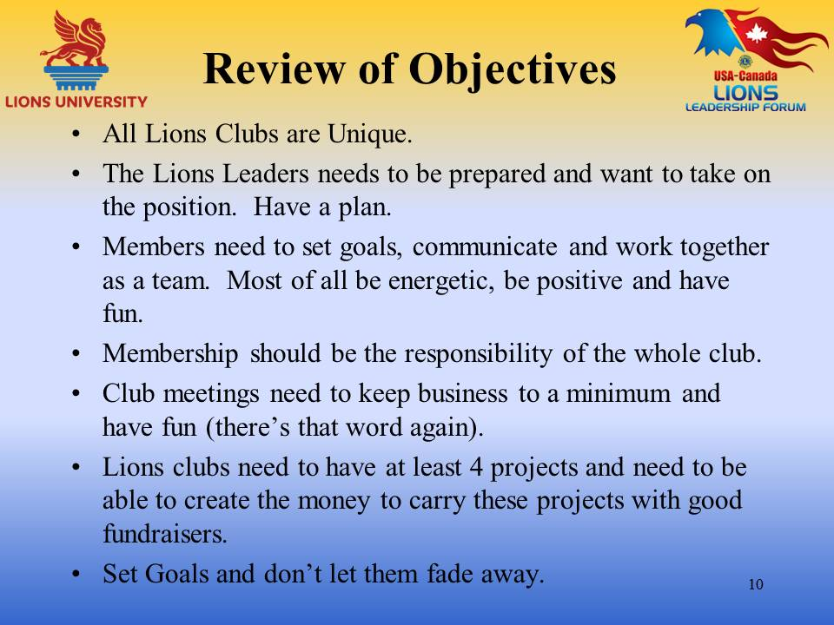 | - All Lions Clubs are Unique.  - The Lions Leaders needs to be prepared and want to take on the position. Have a plan.  - Members need to set goals, communicate and work together as a team. Most of all be energetic, be positive and have fun.  - Membership should be the responsibility of the whole club.  - Club meetings need to keep business to a minimum and have fun (there’s that word again).  - Lions clubs need to have at least 4 projects and need to be able to create the money to carry these projects with good fundraisers.  - Set Goals and don’t let them fade away.
Slide 11 | This ends our course on Club Success!  We hope you have enjoyed the interaction, and are able to take away some important and useful ideas!  In order to get credit for this course through Lions University, you will need to register for an account and/or login to http://www.LionsUniversity.org/  Navigate to the Bachelor Program listing and this course. After participating in a live course, select “Mark as Completed” and the quiz module will be made available.  You are able to track your course completion progress real time.  You can utilize any of the notes, information and materials from this webinar. Good Luck!
Slide 12  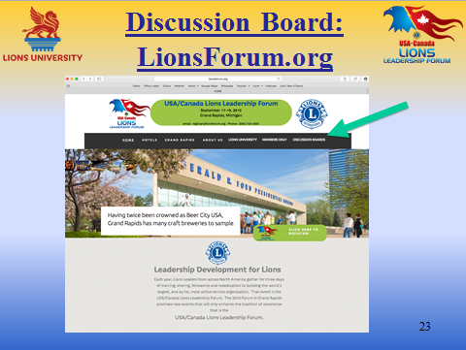 | You can also participate in the discussion about this topic or other Lions University course topics by going to the http://LionsForum.org web site.

