Slide 1  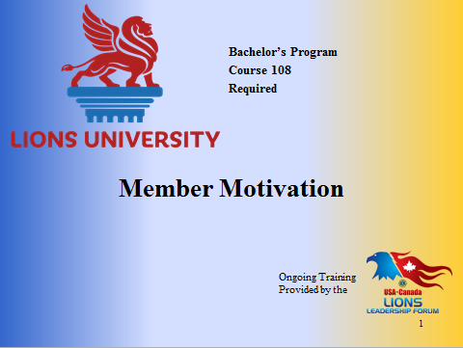 | Welcome to Member Motivation.  This course content was prepared by PDG Judy Dudley from Multiple District 8, Louisiana for Lions University and the USA/Canada Lions Leadership Forum.  This material has been made available for District and Multiple District leadership development.  You will be able to get credit for participating in this live seminar through Lions University by later taking an online quiz.
Slide 2  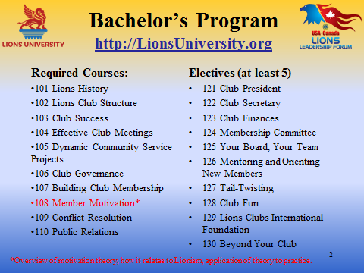 | Member Motivation is course #108, a required course for the Lions University Bachelor’s Program that is designed to help Lions lead at the club level.  The Bachelor’s Program involves the completion of ten required courses and at least five elective courses.
Slide 3  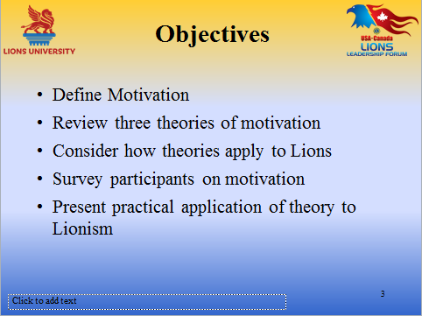 | Our objectives tonight are to:  - Define motivation  - Look at some motivation theories  - Consider how the theories apply to groups such as Lions Clubs  - Survey all of you by asking you to answer some questions about motivation  - Present some practical applications of theory to practice  Can you or can I motivate Lions or anyone else for that matter? I believe the answer to that question is both yes and no. We all can certainly motivate ourselves. Unfortunately we cannot pass that motivation on directly nor can we go to the pharmacy to purchase a motivation capsule or tonic. What we can do is decide to use the behaviors that will encourage other Lions to be motivated themselves through engagement and inspirational leadership.
Slide 4  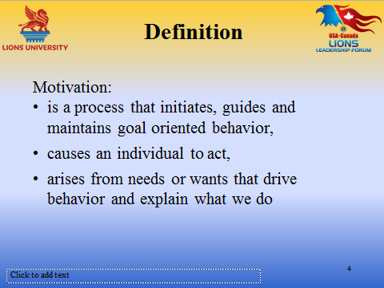 | In a sense, we are considering motivation as a process that causes Lions to work toward established goals: it arises from internal feelings about external stimuli.  I cannot motivate you, but if I know you well enough I can ensure that stimuli are present that will cause you to want to act in a particular manner.  Motivation is internal to the actor rather than caused externally by someone or something else.
Slide 5  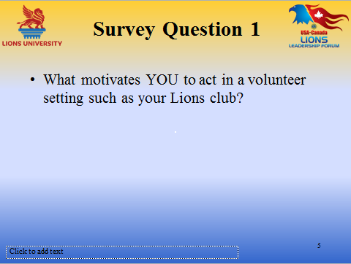 | What motivates YOU in a volunteer setting such as your Lions Club?  [Share responses]
Slide 6  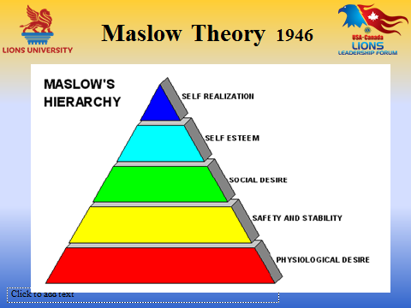  Slide 6 (continued) | Abraham Maslow introduced the Hierarchy of Needs that was based on the premise that the most basic of needs must be satisfied before an individual can progress to needs at a higher level. His theory is often represented using a triangle with the most basic needs being at the bottom.  In this illustration the most basic needs are called physiological needs. I like to refer to this level as Survival. The needs at this level include food, water clothing. Unless the basic needs are satisfied all of an individual’s activity will be at this level. Would this individual have the time and resources to be a Lion?  The second level is Safety and Security. At this level one is motivated to find shelter, protection and safety from harm. If an individual’s safety or security is in danger, other things don’t seem to be important.  The third level is Social Needs – belonging to a group. This is a need not only to interact with others, but also to belong – to feel like part of the group. An individual now would be motivated to join a Lions Club.  The fourth level is Self Esteem. How you perceive yourself can be a strong motivator for behavior. Interestingly not everyone’s need for self-esteem is satisfied in the same way. Some individuals feel high self-esteem by having many friends, by just being accepted part of the group. Others need the power of a title or a leadership position, and still others desire to perceive themselves as serving others and bringing good to their communities. Each of these factors, and many others, can motivate an individual to join a Lions club and fulfill his/her need for self-esteem.  The fifth level is Self-actualization. Being the best that you can be. Maslow believed that only few people reached this level. I believe that many Lions reach this level.
Slide 7  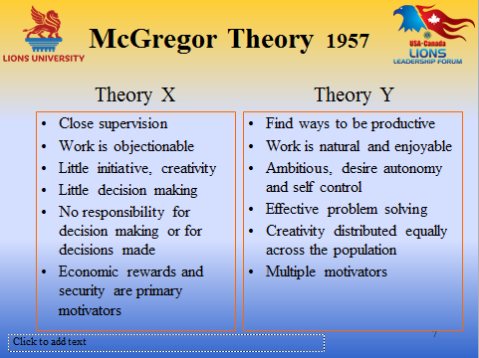 | Theory X and Y is an interesting theory proposed in 1960 by Douglas McGregor in a book called The Human Side of Enterprise. McGregor proposed two motivation theories describing how leadership viewed employees.  As you look at the characteristics of workers seen by their employers, you will see that the characteristics of the employees in each of these theories are directly opposite. It would be my belief that Lions would belong to the Theory Y group. That would suggest that Lion leaders would cause Lions to be motivated by giving them responsibilities and the resources to complete them, by making Lions part of the decision making process in the club, and by rewards and recognition to satisfy their need to know that they had performed well.
Slide 8  Slide image on next page  Slide 8  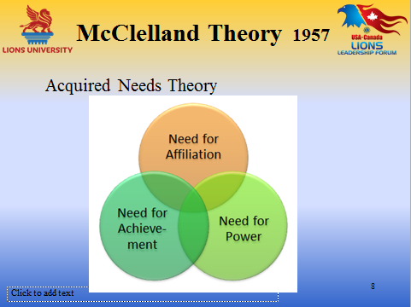 | Douglas McClelland proposed that an individual’s needs are acquired over time and are shaped by one’s life experiences. This is also known as Acquired Needs Theory. Most of these needs can be characterized as being related to Achievement, Affiliation or Power with some overlap as shown by the diagram.  Considering Lions, individuals in each of these categories would be likely to join a Lions club. Some thought should be given, however, to how these very different individuals would be motivated to remain Lions.  High achievers should be given challenging projects with attainable goals. They should be given frequent feedback.  Lions with a high need for affiliation perform best when working with others in a cooperative environment. These are not the individuals who enjoy working on a project by themselves.  Lions with a need for Power like to be presented with leadership opportunities. Committee chairmanship and club offices would motivate them.
Slide 9  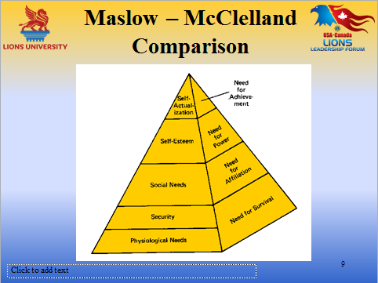 | This slide compares the Maslow and McClelland Theories.  Please note that a fourth need, Need for Survival has been added to McClelland’s needs to correspond to the lower levels of the Maslow Hierarchy
Slide 10  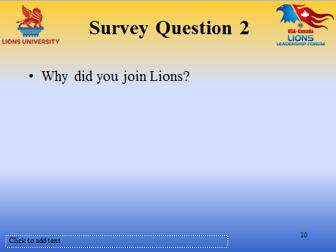 | Please take a moment to answer the question about your motivation to join your Lions club.  [Share responses]

Slide 11  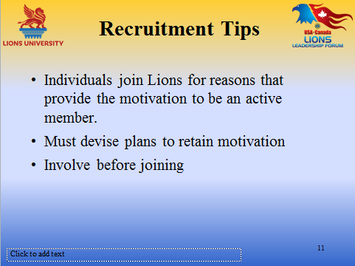 | Individuals join Lions for reasons that provide motivation to be an active member.  They arrive with enthusiasm and with the expectations that their needs will be fulfilled through the opportunities that are presented to them to serve, to lead and to socialize.  Effective orientation of a new member should involve a plan to match activities to the members interests  By giving prospective members an opportunity to be involved before committing to join will give them a better idea of what the club is all about. An invitation to help with a project that interests the prospective member can allow them to experience the special feeling of serving those in need and the other special feeling of bond of friendship that exists in the club.
Slide 12  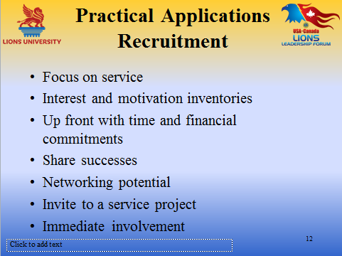  Slide 12 (continued) | Focus on Service: Provide a description of your signature project – the one that identifies your club. Working with youth, Vision Services, Feeding the Hungry  Interest and Motivation Inventories: These could be formal or informal. Ask the prospective member why he or she wants to join the club about special interests, about what they like and don’t like, how do they like to be recognized for accomplishments. This is a two-way street you want to know about your new Lion just as much as your new Lion wants to know about you. Will it be a good match?  Up Front with time and financial commitment: New Lions want to know what will be expected of them. Let them know before they join what their financial and time commitments are. Tell them about dues, how much they are and how they are paid quarterly, semiannually, or annually. Do the dues include the cost of a meal? Are there any other financial expectations of members, like buying a minimum number of barbecue tickets if you aren’t able to sell your quota. About time: When are the meetings and how long might they be expected to last? When are the major fundraisers and projects? How much time is involved? This might seem like too much information, but it is better for a new Lion to know this up front rather than have to resign after joining due to an inability to meet the commitments.  Share successes: Tell the new Lion about the things that you have done. Do you support the Children’s Camp, or have you had a Peace Poster winner? Has someone that your club has helped gone on to no longer need your help? You can share these stories without names and not breaking confidences.  Networking Potential: Tell your prospective member who your club members are and something about them if the new Lion is new to the area, or doesn’t know your members.  Invite to a Service Project: Inviting a potential member to help at a service project is a way to show this possible Lion what we do best. We Serve.  Immediate Involvement: Assign a new Lion to an active committee immediately. It may be that the assignment can be made even before he/she has formally joined. Giving a Lion a responsibility gives that Lion a reason to be at a meeting or an event. Try to keep everyone involved.
Slide 13  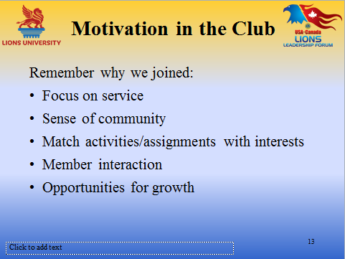 | Remember why we joined.  Focus on Service: Lions sometimes get too tied up in the means and they forget the end-their goal is to serve.  Sense of Community: Work toward a sense of community in your club. This requires Lions getting to know each other so that they can care about each other just as they care about those they serve.  Match activities/assignments with interests: this will ensure that Lions are working from their strengths or using skills that they are interested in building.  Member interaction: It is important that all Lions have the opportunity and time to interact with each other and not just with the same Lions at every club meeting and every event.  Opportunities for Growth: This can be growth in skills, growth in social contacts, growth in service – each one of those factors, or any combination of them can result in a growth in self-esteem, a motivator in itself.
Slide 14  Slide image on next page  Slide 14  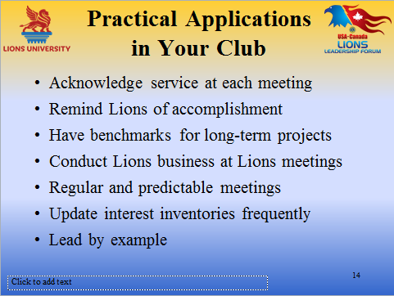 | Acknowledge Service at each Meeting: One club has written a short statement acknowledging what they have done and what they continue to do and they recite it during the opening of each meeting.  Remind Lions of accomplishments: things from the past and more recent service.  Have benchmarks for long-term projects: Long term projects can become tedious. To help keep Lions enthusiastic, celebrate the success of defined benchmarks along the way.  Conduct Lions business at Lions meetings: regular or board meetings. It is quite disheartening for Lions to discover that a few key Lions have made decisions and acted on things that were discussed outside the club and expect club members to rubber stamp after the fact.  Regular and Predictable Meetings: Lions should be able to plan ahead about the dates and times of meetings. They should know if they are going to be dinner meetings and what will be expected of them at the meeting. But predictable doesn’t mean boring. Little surprises from the tail-twister can be a big plus.  Lead by example: A leader should never expect a Lion to do something he or she would not be willing to do himself. A leader should model the behavior that is expected of others
Slide 15  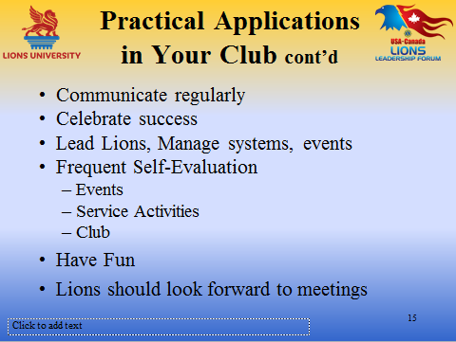  Slide 15 (continued) | Communicate regularly: This is important to keep all Lions involved and on the same page. Electronic communication works well for every day items, but if it is something unusual, time sensitive or extremely important, personal contact is better. If you have included communication on your interest inventory, you can use the primary type of communication selected by each Lion.  Celebrate success: even small successes. A celebration could be as small as a group pat on the back or as large as a full-fledged party – black tie if that’s what your club would like.  Lead Lions, Manage systems or events: when people are led following is their choice and their self-motivation confirms what they will do. When people are managed the whole choice is that of the manager. The choice of the individual is to stay or leave.  Frequent self evaluation: If it is worth doing, it is worth knowing whether we did well.  - Fund Raising Events: Did we achieve our financial goal? Was the profit worth the amount of time and effort invested? Is this something that is supported by our community? If no, was it the event itself, the reason for the fundraiser or some other outside factor that caused the lack of support?  - Service activities: Should be evaluated on a periodic basis to determine whether they are still appropriate for the community and effective for the recipients of help. Would recommend the Community Needs Assessment from LCI.  - Club: Is your club relevant to its members? Is your club relevant to the community? Would suggest doing the Club Excellence Process, and/or the Club Blueprint for a Stronger Club. Both of these programs are available from LCI  Have Fun: The business of being a Lion is serious. It is a responsibility that a Lion takes on in addition to all of his other family, employment, religious and community involvement. A Lions club where the Lions get along well and the members have fun both at work and at play is a club that will last because the members won’t get burned out. Having fun while being a Lion will lighten the load and keep that Lion coming back.  Lions should look forward to meetings: Make the meetings something that Lions don’t want to miss – great food, the joy of being with fellow Lions, and the little unexpected things that happen during the meeting . Put a surprise into the agenda. Give everyone something to do and a reason to be at each meeting.
Slide 16  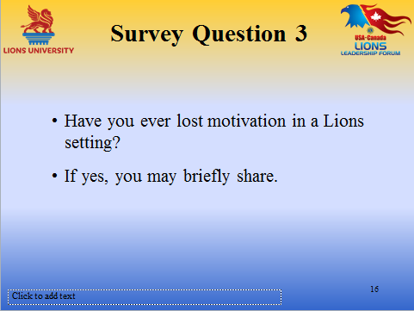 | Have you ever lost motivation in a Lions setting?  If so, you may share if you choose.
Slide 17  Slide image on next page  Slide 17  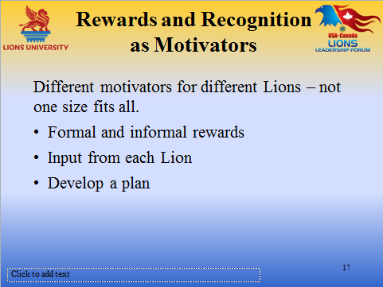 | Not everyone is motivated by public recognition, but I have never met anyone who didn’t appreciate a sincere pat on the back or thank you.  Different motivators for different Lions: Not one size fits all. Some appreciate public recognition, others prefer it be done in private.  Formal and informal rewards/awards: Many of the formal awards are defined by Lions Clubs International or by the district structure. Don’t forget the informal and maybe sometimes silly awards. They sometimes mean more because of the thought and effort of your club or district Lions that went into putting the recognition together.  Input from each Lion: The interest or preference inventory again. Ask the Lions how they would like to be recognized  Develop a plan: Be sure to recognize or congratulate each Lion at some time in the year.
Slide 18  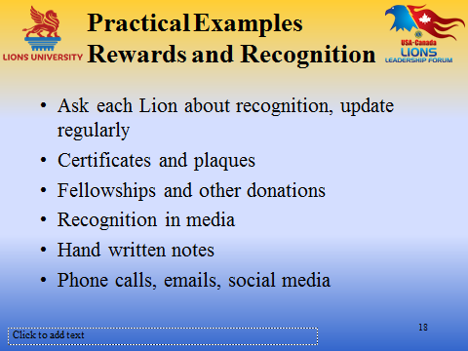 | Survey Lions about Recognition: as part of club information. Update regularly just as you would phone, email, address  Certificates and Plaques: Certificates are easy, inexpensive, and can be made very personal. Caution –make sure they look professional, the printer has plenty of ink of the right color and everything is spelled and aligned correctly. Plaques are getting more expensive every year and many Lions don’t have the space to display them.  Fellowships and other donations: A gift that keeps on giving. The recognition that comes after making a donation in an individual’s name is appreciated not only because of the help that will come to someone in need but also because the recipient realizes the investment of time and effort that went into earning the money to make the donation  Recognition in media: Every Lion deserves the opportunity to appear in a newspaper photo or a television spot. Some may respectively decline, others will appreciate it. It may be the president’s year but it is the Lions who are doing the work.  Hand written notes: One of the least frequent but most appreciated ways to say thank you.  Phone calls, emails, social media: When at all possible, use the most personal.

Slide 19  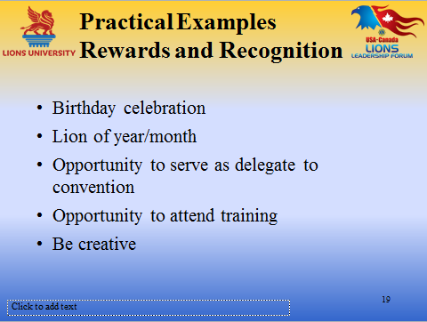 | Birthday celebrations: Every Lion can be honored every year in the month of his/her birthday.  Lion of year/month: a tradition in some clubs, important to pass it around  Opportunity to serve as delegate to convention: This is especially meaningful to new Lions and first-time attendees to a convention.  Opportunity to attend training: For the Lion who joined to acquire new skills or enhance current skills this can be an important form of recognition.  Be creative: Build the reward to suit the Lion. With the diversity of our membership the choice is limitless.
Slide 20  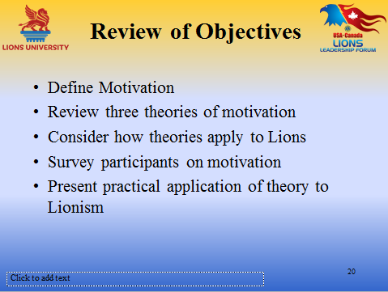 | Let’s review, did we meet our objectives?
Slide 21 | This ends our course on Member Motivation!  We hope you have enjoyed the interaction, and are able to take away some important and useful ideas!  In order to get credit for this course through Lions University, you will need to register for an account and/or login to http://www.LionsUniversity.org/  Navigate to the Bachelor Program listing and this course. After participating in a live course, select “Mark as Completed” and the quiz module will be made available.  You are able to track your course completion progress real time.  You can utilize any of the notes, information and materials from this webinar. Good Luck!
Slide 22  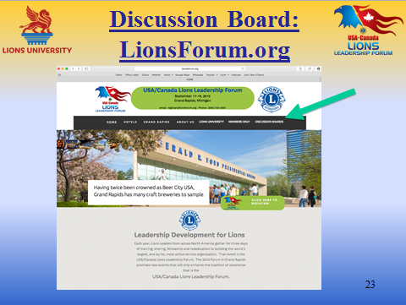 | You can also participate in the discussion about this topic or other Lions University course topics by going to the http://LionsForum.org web site.

