Slide 1  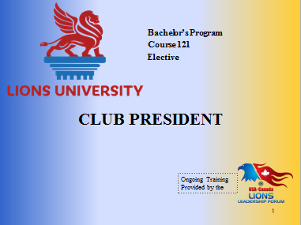 | Welcome to the Club President course.  This course content was prepared by PDG Nancy Watt-Durant from Multiple District A, Ontario for Lions University and the USA/Canada Lions Leadership Forum.  This material has been made available for District and Multiple District leadership development.  You will be able to get credit for participating in this live seminar through Lions University by later taking an online quiz.  [CLICK]
Slide 2  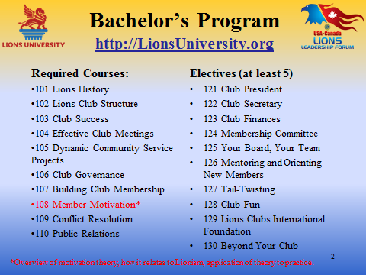 | Club President is course #121, an elective course for the Lions University Bachelor’s Program that is designed to help Lions lead at the club level.  The Bachelor’s Program involves the completion of ten required courses and at least five elective courses.  [CLICK]
Slide 3  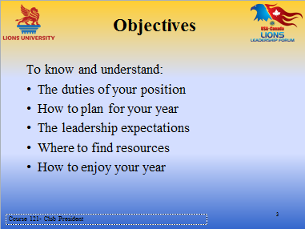 | We have Objectives for our session. At its conclusion you should have a better understanding of  - The duties of your position and how to plan for your year as Club President.  - The leadership expectations that your Lions have of you and how you can fulfill them.  - Where to locate the various resources you will need, and above all, how to enjoy this very special year.  [CLICK]

Slide 4  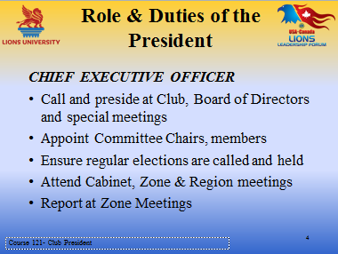 | Well, here you are – the President! – Chief Executive Officer of your club – Congratulations! – here are your duties in a nut shell. [CLICK]  - Call and preside at all the Club, Board and Special meetings during the year;  - working with the Vice Presidents, select and appoint the Committee Chairpersons and Members;  - Ensure that annual elections are held and the results reported to Lions Clubs International;  - as a member of the Governor’s Advisory Committee, attend and report at all Zone Advisory Meetings; and  - represent your Club at Cabinet, Regional and other meetings.  In addition to understanding your role and duties you also need to understand the roles and duties of the Board of Directors, especially the Vice Presidents, Secretary and Treasurer if you are to work effectively with them.  Keep in mind, that as CEO, “The buck stops here!”  [CLICK]
Slide 5  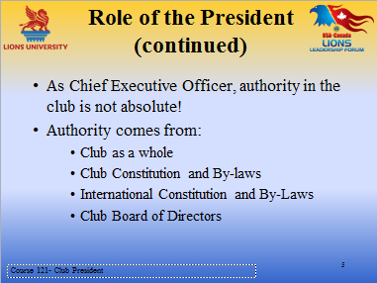 | Although you are the CEO, your authority is not absolute.  Where do you think the President’s authority comes from?  [CLICK]  Here’s what LCI says - first it comes from the club membership as a whole – as they elected you to the position.  Then it comes from the club Constitution and By-Laws (C&BLs) or the Standard Form Club C&BLs if your club does not have its own, and also the International C&BLs and  [CLICK]  The Board of Directors
Slide 6  Slide image on next page  Slide 6  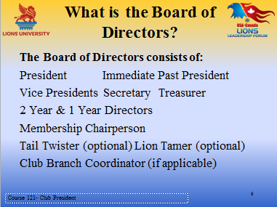 | The President works with Board of Directors to ensure the club runs smoothly. Who are they?  [CLICK]  President, Immediate Past President, the Vice Presidents (1st , 2nd, or 3rd – depending on the size of your Club,) and the Secretary and Treasurer;  The Directors are elected for a two year term, and the number depends on the size and practice of your club. Two Year Directors are brand new and in their first year on the Board, while the One Year Directors are in their second year on the Board. Often Directors are mistakenly referred to as Second Year and First Year Directors; however, their correct titles are Two Year Director and One Year Director. [CLICK]  The Membership chairperson also sits on the Board. [CLICK]  Tail Twister and Lion Tamer are optional positions. LCI made them optional a few years ago and many smaller clubs particularly have eliminated them from their Boards.  And there is one more – if you have a Club Branch, the Coordinator is also a member of your Board of Directors.  [CLICK]
Slide 7  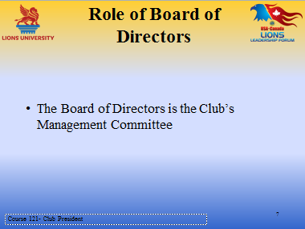 | What is the role of the Board of Directors?  [CLICK]  They are the Management Committee and oversee the operations of the club, and ensure that they are in line with both the club and International Constitutions and By-Laws.  [CLICK]
Slide 8  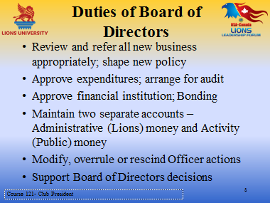  Slide 8 continued | Their duties are pretty straight forward:  [CLICK] ALL new business of any nature is handled first by the Board, then referred to the appropriate club committee for study and recommendations. They consider and shape all new club policy prior to presentation to and approval of the club members.  [CLICK] They approve expenditures in accordance with the Club Budget and ensure that the club does not go into debt. They ensure the books are audited annually and the report is made available to the membership if requested.  [CLICK] They approve the financial institution used by the club. They also should consider bonding for any club Officer or any Lion who is responsible for handling money.  [CLICK] And they make sure that the club has two separate funds – one for Administrative or Lions money – which is money from dues, internal raffles and draws, Tail Twisting, etc. ., and the other for Activity money raised from the public through fundraisers, donations, and the like, and they ensure that the funds are never intermingled. As you all are aware, Activity money is NEVER used for the benefit of your club or any of your Lions members or their families.  [CLICK] The Board has the power to modify, overrule or rescind the unauthorized or inappropriate action of any Officer of the club, which of course includes the President.  [CLICK] Support Board of Directors decision – the Board members should show a united front when making recommendations to the club – the only exception would be if some new startling information became available after the Board decision . . . Otherwise, stick to the original decision, even though you may not have initially been in favour.
Slide 9  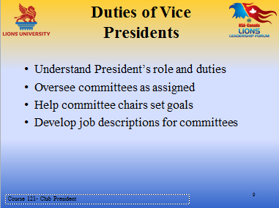 | Vice Presidents have additional duties – It makes sense they fully understand the President’s role and responsibilities as they may have to stand in for the President at some time.  [CLICK] They work with the Committees that have been assigned to them,  [CLICK] By helping the Chairs to set goals and create action plans to ensure the goals are achieved  [CLICK] and along with the Committee Chairs, develop job descriptions so that the committees understand their mandate.
Slide 10  Slide image on next page  Slide 10  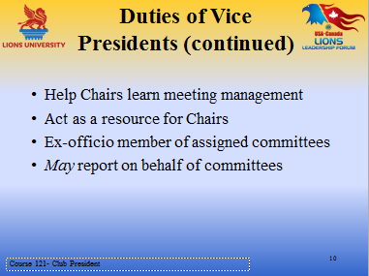 | They can assist the Chairs in planning and effectively chairing meetings  [CLICK] And act as resource persons and sounding boards for the chairs and committee members  [CLICK] As they are ex-officio members of their assigned committees – they should attend some of their meetings – but they do not have a vote.  [CLICK] Depending on how your club works, Vice Presidents may report on behalf of their committees to the Board of Directors and the Club.  And most importantly, they assist but do not take over the functions of the Chairs or committee members.  You can see that the Vice Presidents are active and essential to the functioning of the committees.  [CLICK]
Slide 11  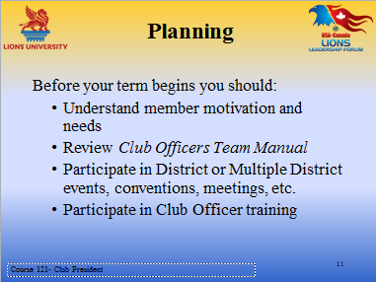 | An effective year starts with good planning. As with every other aspect of our lives, from a family trip to doing something at work, planning is important.  Remember ……. “If you FAIL to plan, you PLAN to fail!”  Here are some useful things to consider before you take office . . .  [CLICK] Find out what gets Lions enthused and what they may need to help them become good active club members  [CLICK] The Club Officers Team Manual is online at Lions Clubs International website in the Member Center under Resources. It contains a wealth of information and help on every aspect of leading your Club. It also covers the roles, duties and responsibilities all the other officers. It is an excellent resource for the whole team.  [CLICK] By attending and participating in District and Multiple District events, you will broaden your horizon by sharing with and learning from other Lions.  [CLICK] And we cannot overstate how important it is to participate in every Club Officer training event. And by taking this course, you have indicated that you understand this.  [CLICK]

Slide 12  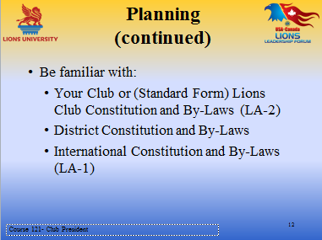 | And here are some documents you should be familiar with, particularly the Club C&BLs.  The Standard Club and International Constitutions and By-laws are online at Lions Clubs International website and your District C&BLs should be available from your District C&BLs chair or any District Officer. Many Districts have them on their websites.  [CLICK]
Slide 13  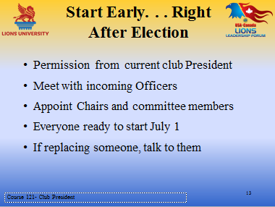 | Good planning starts early . . . As a courtesy, ask the President if he or she would mind if you started to work with the in-coming Officers and get things underway for a smooth transition for the coming year.  [CLICK] Meet with the incoming Officers and start working on your plans, and also look to present Officers for assistance.  [CLICK] Work with the Vice Presidents to select Lions to Chair committees and to sit on Committees, and assign the Vice Presidents to their various committees  [CLICK] You want everything and everyone in place and ready to go on July 1st.  [CLICK] And I can’t stress enough how important this last point is – replacing a Lion. Nothing is worse than hearing second hand you are being replaced! Approach the Lion and explain you appreciate the hard work and leadership that he or she has contributed by working in this capacity and you would like to give another Lion the same opportunity to develop new skills by taking on this position. Offer this Lion other positions that you believe would benefit from his or her expertise. Let the person know you really value their support and want him or her on your team.  [CLICK]
Slide 14  Slide image on next page  Slide 14 | Just as the Vice Presidents need to understand your role and responsibilities, you need to understand what the Secretary’s and Treasurer’s positions entail so you can work effectively with them and coach them if necessary.  [CLICK] Meeting with them to review some of their duties and becoming aware of things they may require some assistance with will strengthen your team.  [CLICK] Accurate record keeping needs to be stressed with both parties. The various records need to be kept up to date and filed appropriately.  [CLICK] Regular reporting to the Board, Club members and other interested parties means good communications and well informed Lions.  [CLICK] Signing authority is usually given to two of three designated officers, and as noted earlier, the Board of Directors should consider bonding of any Officer and other Lion responsible for handling money.  [CLICK]
Slide 15  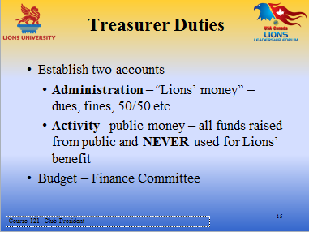 | The Treasurer should ensure a bank account or accounts are set up, as are required, in accordance with Board of Directors policy – and that Administration (Lions money) and Activity or Public monies are always accounted for separately.  [CLICK]  The Treasurer may be the Finance Committee chair –it depends on your club. If not chair, the Treasurer should definitely be a member of the committee. The responsibility for drawing up the budget is the responsibility of the Finance Committee, working with the Treasurer.  [CLICK]
Slide 16  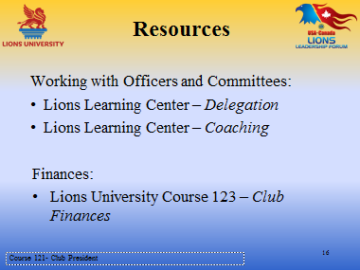 | Here are some Lions Clubs International on-line courses designed to help you work effectively through delegation and coaching the Officers and Committees.  Specifically regarding Finances – refer the Treasurer to the Lions University course #123.  [CLICK]
Slide 17  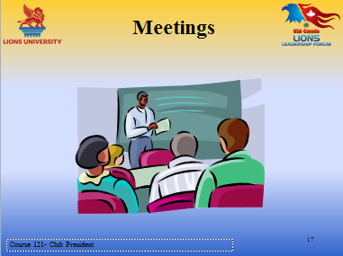 | How to plan and run effective meetings is a whole topic unto itself. So we will briefly cover some of the things you will need to know and do  [CLICK].
Slide 18  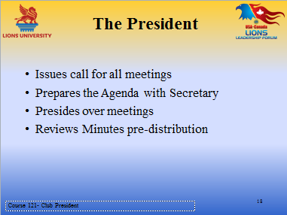 | As President you Issue the call for all regular club, Board of Directors and special meetings.  [CLICK] Work with the Secretary to prepare the Agenda  [CLICK] Preside over the meetings and  [CLICK] You should review the Minutes prior to distribution to ensure they are correct and reflect what occurred at the meeting.
Slide 19  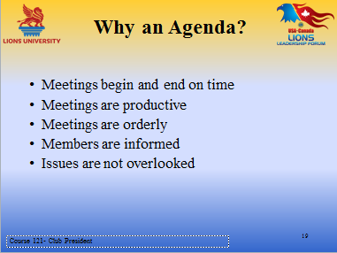 | Now, here’s a good question for you: Why should we have an Agenda?  (Participant input).  [CLICK]  Of course – and these are the main reason we need an agenda and we need to follow it.  - Meetings begin and end on time  - Meetings are productive  - Meetings are orderly  - Members are informed  - Issues are not overlooked  [CLICK]

Slide 20  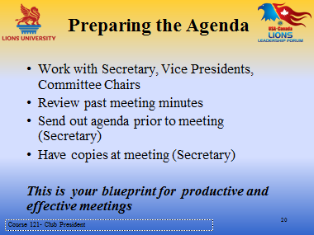 | When preparing the Agenda [CLICK]  - Work with the Secretary, and get input from Committee chairs and Vice Presidents.  - Review prior Minutes to ensure everything gets on the Agenda.  - The Secretary should send it out a few days prior to the meeting and should have a few paper copies at the meeting in case someone has forgotten to bring theirs.  [CLICK] A good Agenda that is followed is your blueprint for a good productive meeting!
Slide 21  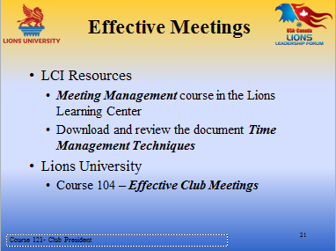 | For more detailed information, be sure to use LCI’s on-line resources to assist you in learning how to hold effective meetings.  And also the Lions University Course # 104 – Effective Meetings  [CLICK]  And one last point – you need to understand and use Parliamentary procedure.  [CLICK]
Slide 22  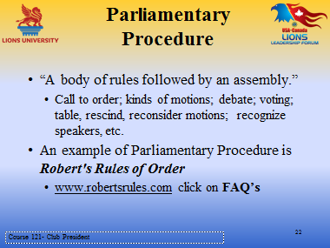 | Parliamentary procedure is how Lions Clubs International conducts all their meetings and asks that Clubs do the same.  It is a body of rules followed by an assembly and helps us know the procedure for making motions, voting, debating an issue, etc.  [CLICK] An example of Parliamentary procedure is of course Robert’s Rules of Order which many of you may already be familiar with.  There is a website – www.robertsrules.com which is very helpful with the commonest procedures we would use in our meetings.  Just click on FAQ’s and it’s there!

Slide 23  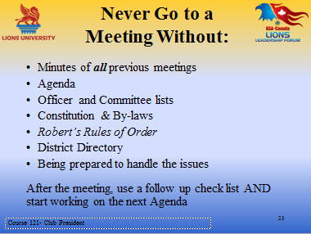 | In summing about meetings, - It is essential you be fully prepared for all your meetings to never leave home without  [CLICK]  - Minutes of all prior meetings;  - your Agenda;  - Officer and Committee lists;  - Constitution and by-laws;  - Robert’s Rules of Order;  - your District Directory ; and  - knowing what the issues might be and being prepared to handle them in an effective manner.  [CLICK] And your homework after the meeting is to use your check list to ensure you didn’t miss anything, then start working on your next Agenda.
Slide 24  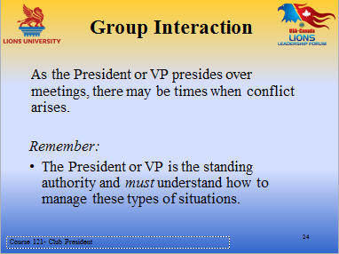 | Unfortunately, conflict may arise on occasions and it is important for everyone to understand that the Lion in the Chair – President, Vice President or Committee Chair - is the standing authority.  To assist you in learning some techniques to handle conflicts  [CLICK]
Slide 25  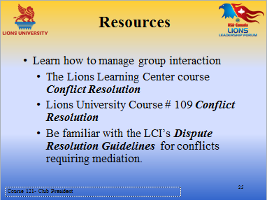 | Lions Clubs International has some courses that will help you manage group interactions  [CLICK]  - Conflict Resolution on the LCI’s Learning Center,  - Lions University Course 109 – Conflict Resolution, and  - LCI’s Dispute Resolution Guidelines.  [CLICK]
Slide 26  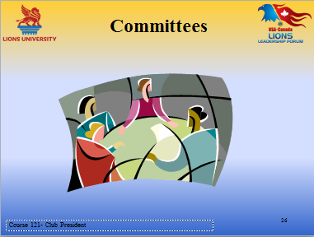 | Now let’s look at Committees  [CLICK]
Slide 27  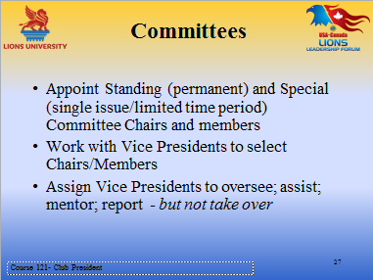 | Appoint the Standing committee such as Membership, Finance, Nominations, C&BLs, to name just a few.  Special issue or limited time committees - such as Club Rebuilding, or meals, etc. - are struck for one special issue and only for as long as it takes to resolve the issue.  [CLICK] And as noted before, assign the Vice Presidents to oversee, assist and mentor their various committees, but to keep in mind at all times that their job is to coach and oversee, but not to take over!
Slide 28  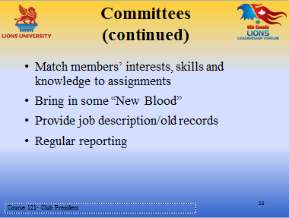 | To ensure your club has good functioning committees.  [CLICK] When selecting Committee Chairs and Members try to match up their interests and skills with the job. And don’t be afraid to bring in some new blood to revitalize committees.  [CLICK] If there are no job descriptions that explain the committee’s mandate, the Vice Presidents can work with the committees to put something down on paper so there is something concrete for the committees refer to, and also to pass on to future committees as a guide. Refer to old records for helpful info on prior activities  [CLICK] The responsible Vice President or the Chair can report to the Board of Directors and membership – and it should be done regularly as the fundraisers or projects are being planned, are underway, and after they are completed. [CLICK]
Slide 29  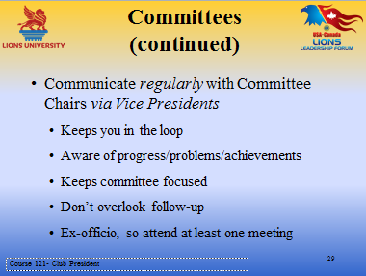 | Communication is key to making sure Lions know what is going on and what is expected of them. So keep in touch with the Committees through the Vice Presidents:  [CLICK] This will keep you in the know and aware of how they are functioning, and will also keep the committees focused on their tasks  [CLICK] If there are problems or concerns, follow-up is essential. Lions then know you are serious about the issues.  [CLICK] And like the Vice Presidents, you are an Ex-officio member of all committees, so let Lions know you are interested in what they are doing by attending some of their meetings.  [CLICK]
Slide 30  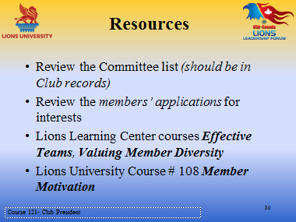 | Here are some ways to help you and the Vice Presidents get the best Lions for the job and also some on-line resources you all can use.  [CLICK] By reviewing committee lists you know who has served before so you can try and get some other members involved. And by looking at applications you can match interests and skills with the Lions you wish to select to serve.  [CLICK] The LCI on-line Learning Center resources are – Effective Teams, Diversity and at Lions University, Course # 108 Member Motivation.  [CLICK]
Slide 31  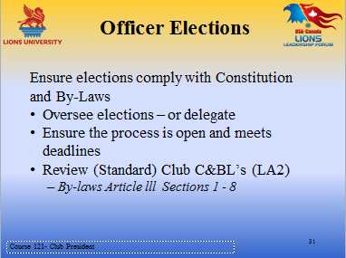 | As President you play a key role in ensuring elections are held every year and they comply with the Constitution and By-laws.  [CLICK] You can oversee the process, or you can delegate it to a responsible Lion in the Club.  [CLICK] Be sure all Lions are aware of the procedures and feel that they are part of the process, not just bystanders And, keep deadlines in mind – for example the election should be held no later than May 15 when the results should be reported to LCI.  [CLICK] To ensure you know and understand the process, review your Club Constitution & by-laws and the Standard C&BLs on line at Lions Clubs International website – especially Article 3, Sections 1 through 8. [CLICK]
Slide 32  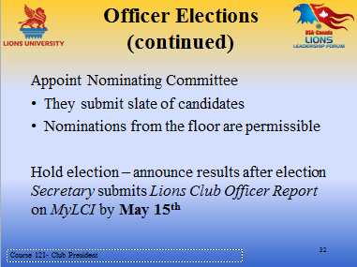 | Appoint the Nominating Committee – They will be responsible for submitting a slate of candidates for the vacant positions. The process is democratic, so nominations may also be made from the floor of the nomination meeting, preferably with the proposed candidate's prior permission.  [CLICK] Hold the election and announce the results. Although the Secretary reports to LCI , it is your responsibility to follow up and ensure this has been done. Lions Clubs International sends info directly to Secretaries, Presidents, and Membership Chairpersons, so it is important that LCI has their names in the data base. Once June 30 has passed, the current info does not transfer to the new year, so you can see how important it is to send the report.  [CLICK]
Slide 33  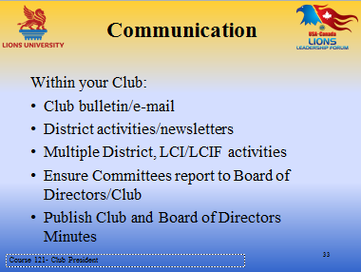 | A club lacking effective communication is more likely to have dissatisfied members who do not feel connected to the club.  Let’s hear some ideas about how we can keep our club members informed (participant ideas/input)  [CLICK]Thanks for your input – some excellent ideas!  Whether you have a printed bulletin/newsletter or use e-mail – get the information out to your members – someone needs to be in charge of this – either a Bulletin editor, or the Secretary if you don’t have an editor.  [CLICK] Ensure that all information you receive is passed along to the membership – don’t assume they also have received it. So forward everything from your District, Multiple, Lions Clubs International, and our Foundation. And if they have received some of it already, my theory is that it is better to get it twice than not at all!  Committees should report regularly to the Board of Directors and the Club, and Club and Board Minutes can be sent out via e-mail or published in your bulletin.  A word about e-mail – we know not all Lions are on line, so be sure they are also in the communications loop by pairing them up with Lions who have e-mail and ask that they ensure that copies of the information are passed along. A small budget can be set to cover the cost of paper and printing if there is a lot of copying to be done.  [CLICK]
Slide 34  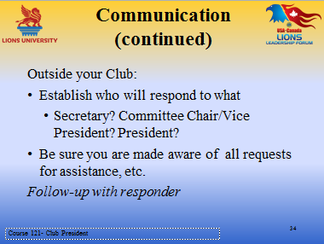 | Outside your Club – Again , let’s have some of your ideas about communication with the public (participant ideas/input)  Again – thanks for your ideas – all very good.  [CLICK] Establish a protocol for responding to correspondence, enquiries, requests for assistance, etc. – decide who is going to take responsibility – Secretary, Vice President or Committee chairperson, President  [CLICK] You need to be aware of all of the issues - so if you get a call, you know what it’s all about. And – follow up within a reasonable time frame with the responder to ensure that action has been taken.  [CLICK]
Slide 35  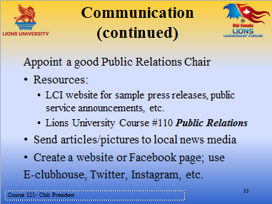 | Use whatever means you can to get the Lions message out to the public A good Public Relation /Publicity Chair is essential. An excellent resource for this Lion is Lions University Course 110 – Public Relations  [CLICK] He/she should write articles and send them with pictures to the local media. Invite the newspaper editor to your meeting or a service project or fund-raiser so he/she can get to know your club and take an interest in what you are doing.  [CLICK] And of course, use all the social media at your disposal - create a Facebook page, a website; use E-Clubhouse; Twitter, Instagram etc. And be sure that your data is current at all times!  [CLICK]
Slide 36  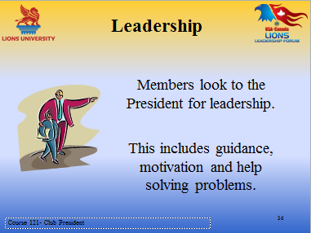 | You are the leader in your Club, and naturally the Lions will look to you for guidance and help in problem solving, as well as creating an atmosphere in which they will be motivated to participate in all aspects of Club life.  [CLICK]

Slide 37  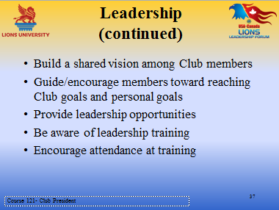 | Encourage Lions to work towards building a shared vision for your Club. This will ensure Club goals are met, as well as Lions’ personal goals.  One way to build a vision for the club is through the Club Excellence Process or CEP. Check this out on the LCI website – just type in CEP in the Search pane of the MemberCenter and there it is. Really worth thinking about if you have not already participated.  [CLICK] Provide leadership opportunities by giving Lions responsible jobs and let them get on with them. Coach and encourage – don’t interfere or worse still, take over as soon as things seem to go astray.  [CLICK] Learning opportunities are endless – Webinars both by Lions Clubs International and now Lions University, as well as many Multiples and Sub-Districts; Institutes such as Emerging Lions and Advanced Lions Leadership as well as Faculty Development; USA/Canada Lions Leadership Forum  And lead by example – attend these opportunities yourself and invite Lions to join you.
Slide 38  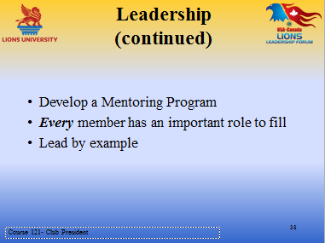 | [CLICK] Use the Lions Mentoring Program – check it out on the LCI Learning Center and Lions University Elective Course # 126 Mentoring and Orienting New Members.  [CLICK] Remember - There is a place for every Lion in your club – you just have to work with that Lion and help him or her find their place.  [CLICK] Lead by example – walk the walk and talk the talk.
Slide 39  Slide image on next page  Slide 39  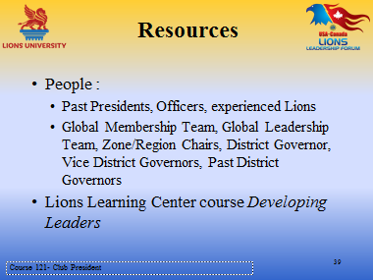 | Resources are not confined to on-line and written materials, people are also resources.  Don’t overlook Lions who can assist you:  - Past Presidents,  - Officers,  - your District Governor and Vice Governors,  - the Global Leadership and Membership team members,  - and many others.  These Lions have a wealth of knowledge and experience that you can tap into.  Mentoring has been mentioned – you too should have a Mentor or Mentors – and these Lions form a pool of people who can be invaluable to you.  [CLICK] And on-line here is another LCI resource for you – Developing Leaders.  [CLICK]
Slide 40  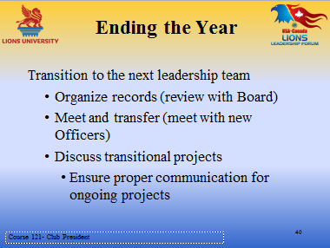 | Here we are at the end already and you’ve just taken office!  Start to plan the end of your year as soon as you take office, if you do, you’ll make sure records are up to date at all times; project plans and reports are completed and in the committee files; reporting is up to date . Don't be a procrastinator . . .  [CLICK] You and the Board should review records to ensure they are complete and ready to be turned over when you meet with the incoming Officers – to assist them with the transition. Ongoing projects need to be reviewed to ensure nothing falls between the cracks. Encourage the President- and Vice Presidents-elect to start working on plans and committees as you did just after you were elected.  [CLICK]
Slide 41  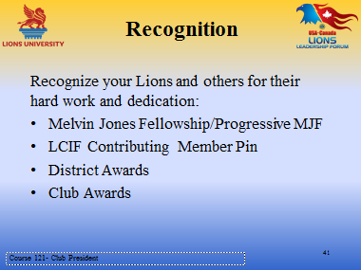  Slide 41 continued | Although recognition should be given throughout the year, it’s always wonderful to have a big celebration at the end of the year and present special recognitions.  Plan a special meeting, a party – whatever it is your club does to mark the end of the Lions Year. Ask a District Officer to come and help make presentations, and be sure to invite the media – or send them a write up and pictures. Be sure to include family members and also invite community volunteers that have helped you out during the year.  This is the time to thank and recognize Lions, their families and the other volunteers for their dedication, support and hard work, and here are some of the ways it can be done . . .  [CLICK]  Melvin Jones Fellowship or Progressive Fellowship from our Foundation; also from our Lions Foundation - Contributing Member pins donations; then there are District Awards you may be able to recommend Lions for and of course your own Club awards.  A word about awards – they should be given in recognition of achievement and contributing to the success of the club, the community and beyond – not just to your favourite Lions. A good solution to this problem is to strike an Awards Committee – it makes the job a lot easier and it reduces bias.  [CLICK]
Slide 42  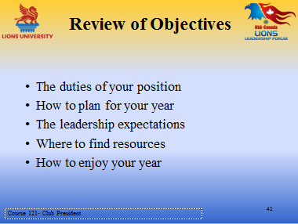 | When we began our Objectives were stated – that by the end of this session you would be aware of and understand  [CLICK] Your presidential duties and how to plan for a successful year. The Leadership expectations of your Lions and how to fulfill them. What resources are available and how to access them.  We believe that with good preparation and thoughtful carrying out of your duties as President that you can say at its completion that you truly enjoyed the experience.  [CLICK]
Slide 43  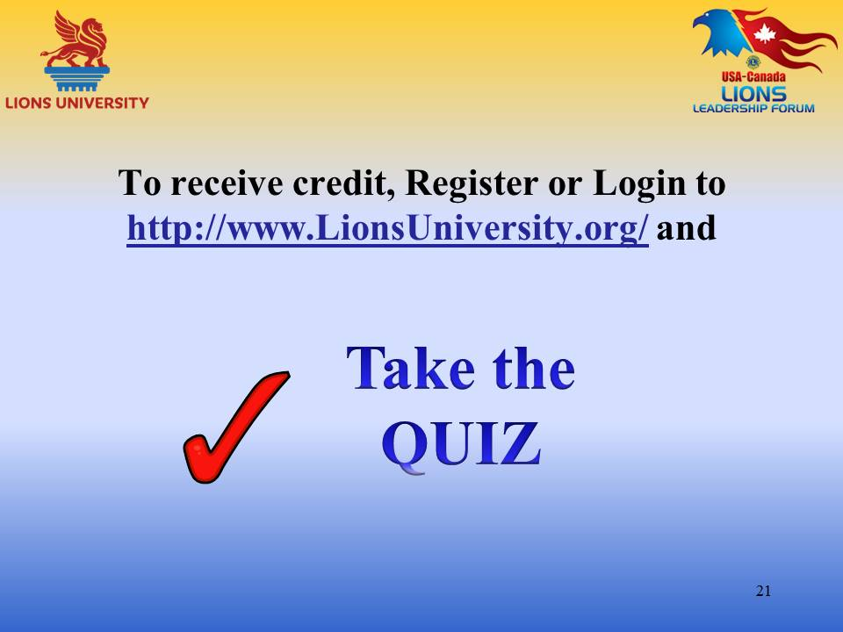 | This ends our course on Club President!  We hope you have enjoyed the interaction, and are able to take away some important and useful ideas!  In order to get credit for this course through Lions University, you will need to register for an account and/or login to http://www.LionsUniversity.org/  Navigate to the Bachelor Program listing and this course. After participating in a live course, select “Mark as Completed” and the quiz module will be made available.  You are able to track your course completion progress real time.  You can utilize any of the notes, information and materials from this webinar. Good Luck!

Slide 44  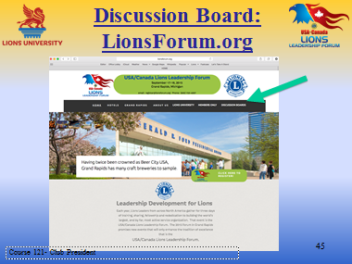 | You can also participate in the discussion about this topic or other Lions University course topics by going to the http://LionsForum.org web site.

